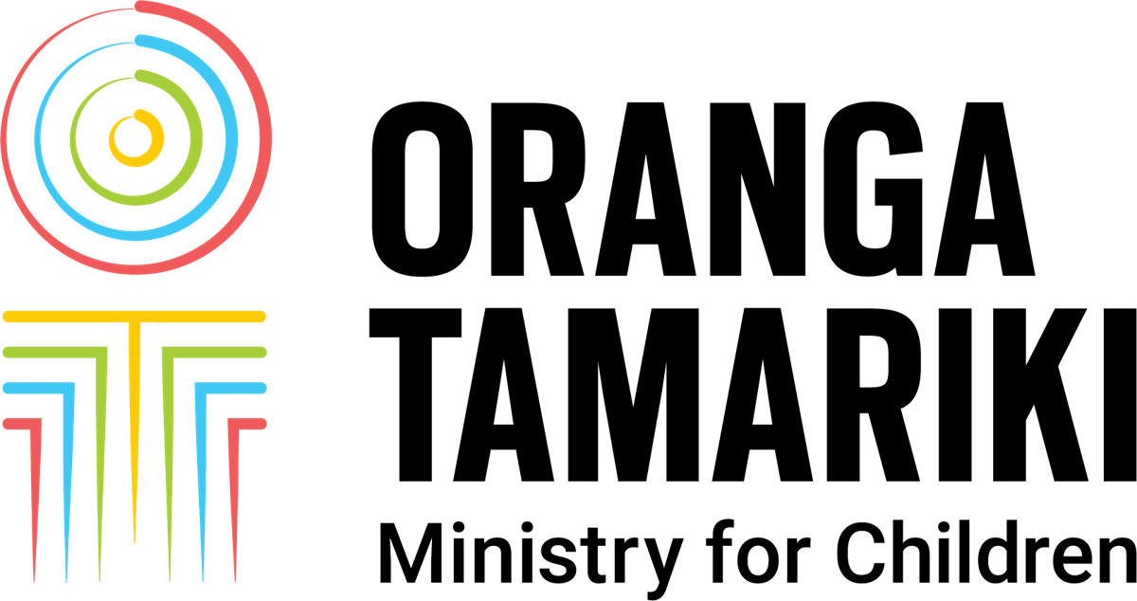
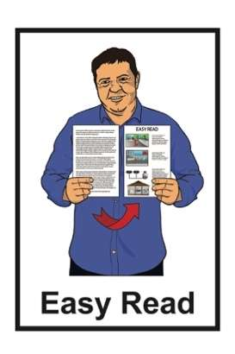

Te Mātātaki 2026: summary


What tamariki and rangatahi told us
about being in care

Published: August 2026

What is in this document


Page number:

About this Easy Read 3
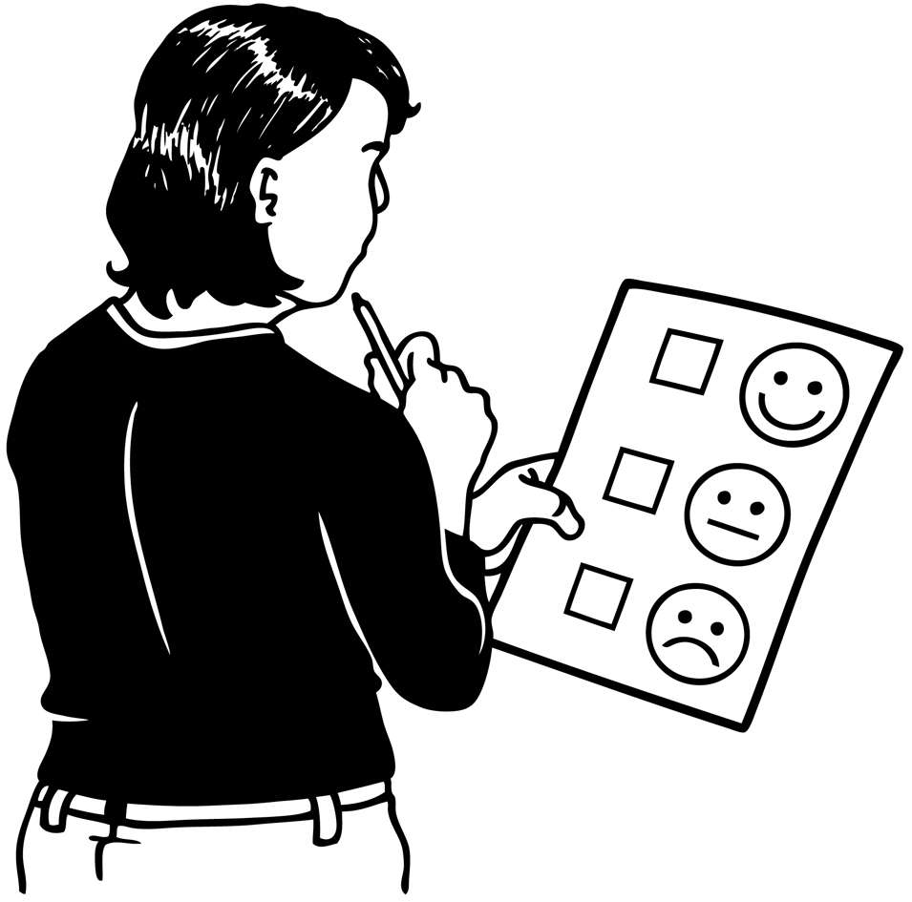

About the survey 6

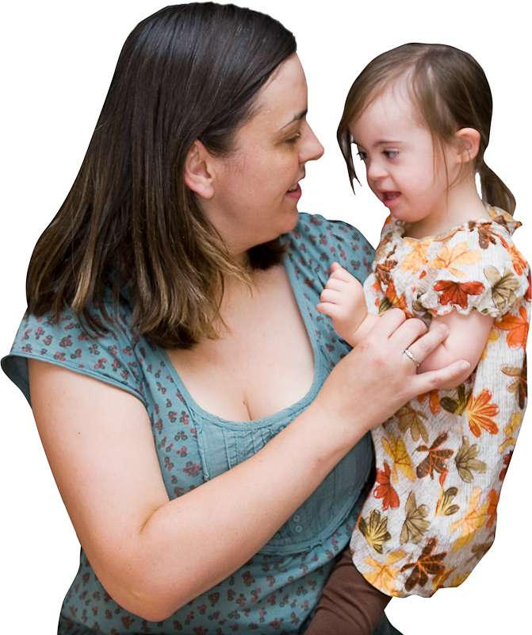
What tamariki and rangatahi
told us 12

Experiences of being in care 16
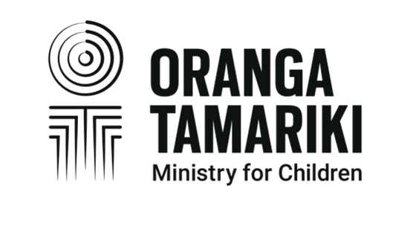

The role of Oranga Tamariki 20


Differences across tamariki
and rangatahi 21

Page number:

In their own words 25

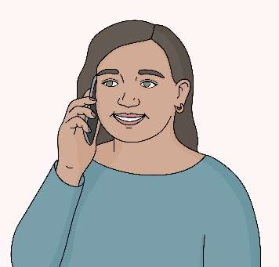
Priority areas for action 29

Contact us 36

About this Easy Read

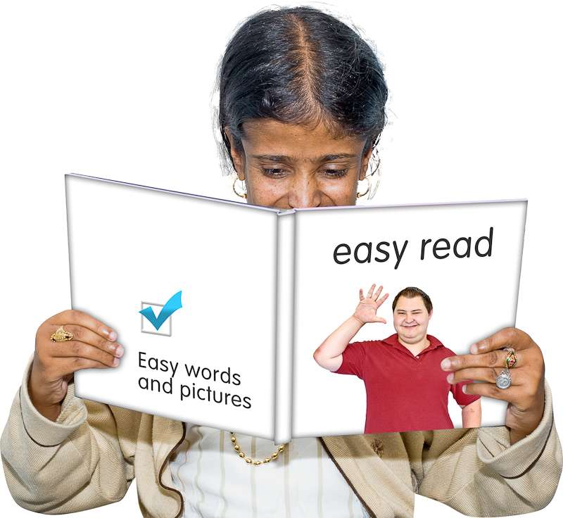
This Easy Read is a summary of a report from Oranga Tamariki Ministry for Children called
Te Mātātaki 2026.

A summary:

is shorter than the main document
tells you the important ideas.

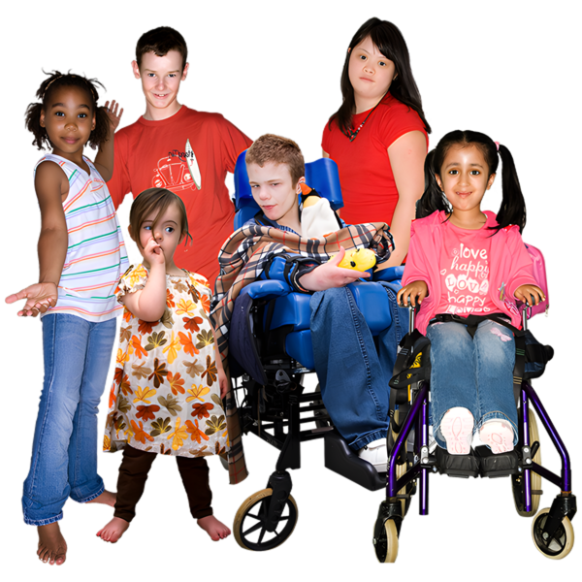
Oranga Tamariki Ministry for Children is the part of the Government that takes care of the needs of:
tamariki / children
rangatahi / young people.
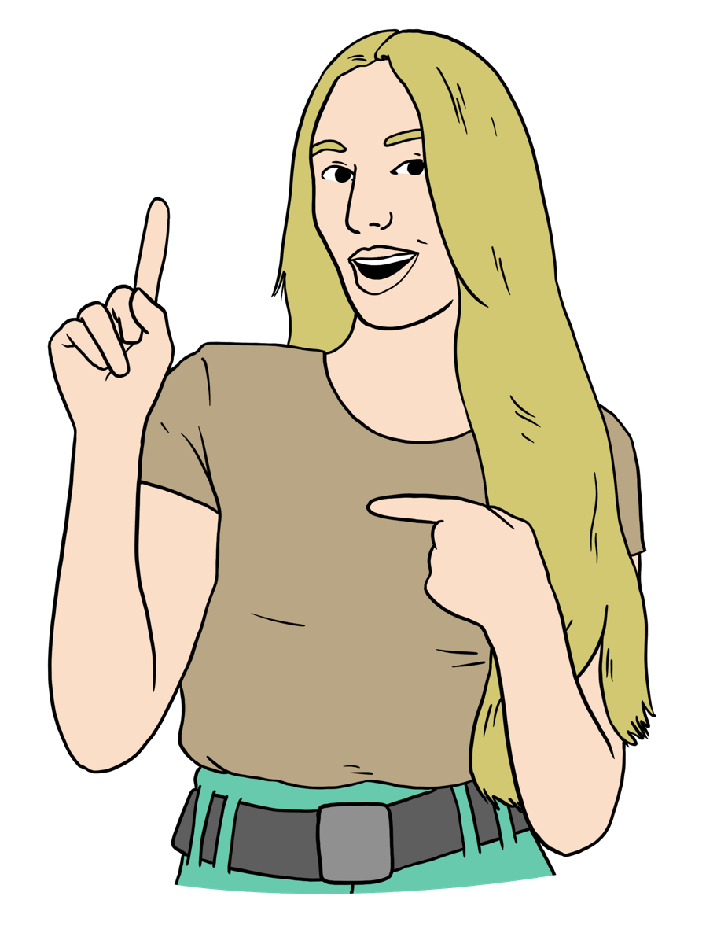
In this Easy Read we / us / our means Oranga Tamariki Ministry for Children.

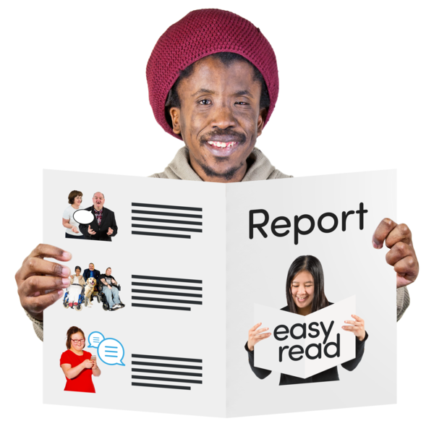
Te Mātātaki 2026 is a report about what we have found out from year 3 of Te Tohu o te Ora.

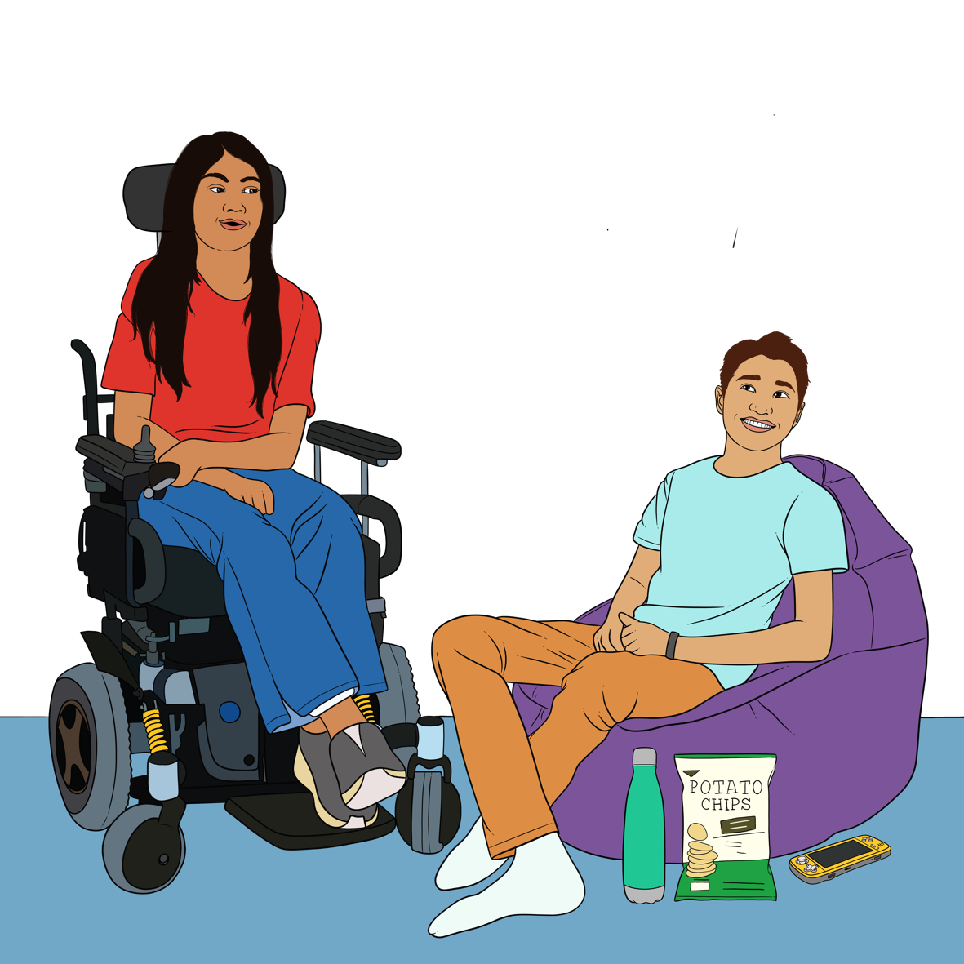
Te Tohu o te Ora is a survey we do often to find out about the experiences of tamariki and
rangatahi in care.


A survey is a list of questions used to find out what people think about something.


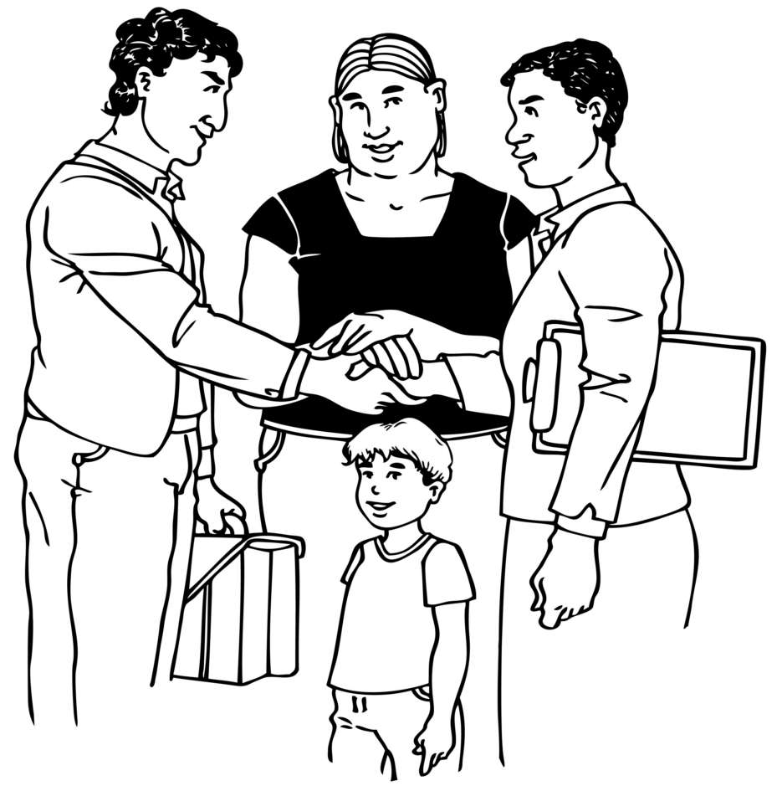
In care means the tamariki and
rangatahi that are being looked after by the Government.


Tamariki and rangatahi in care may live:
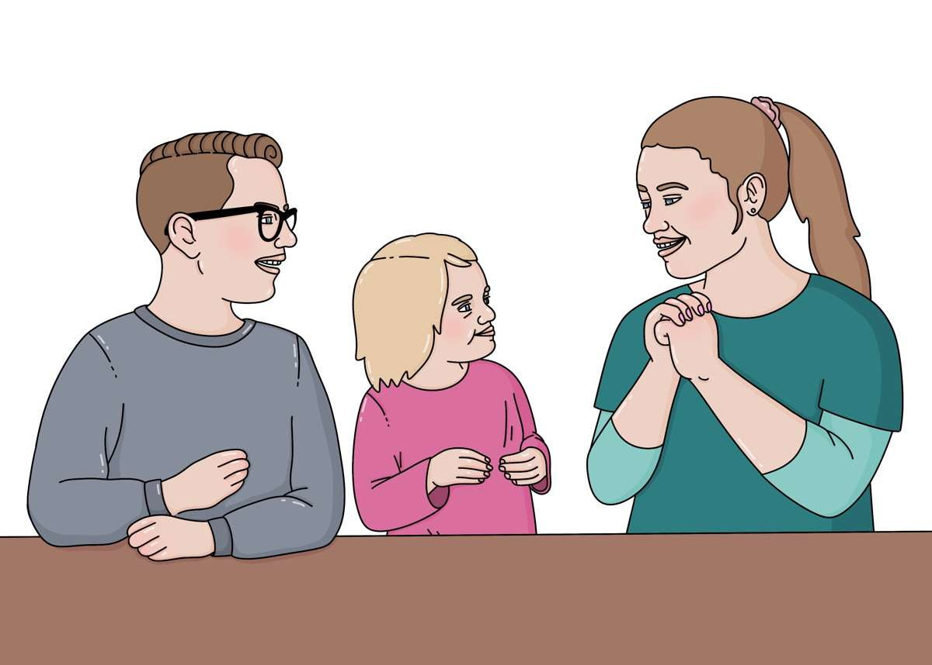
with foster carers / people who look after children in their home for us
with whānau / family
like grandparents
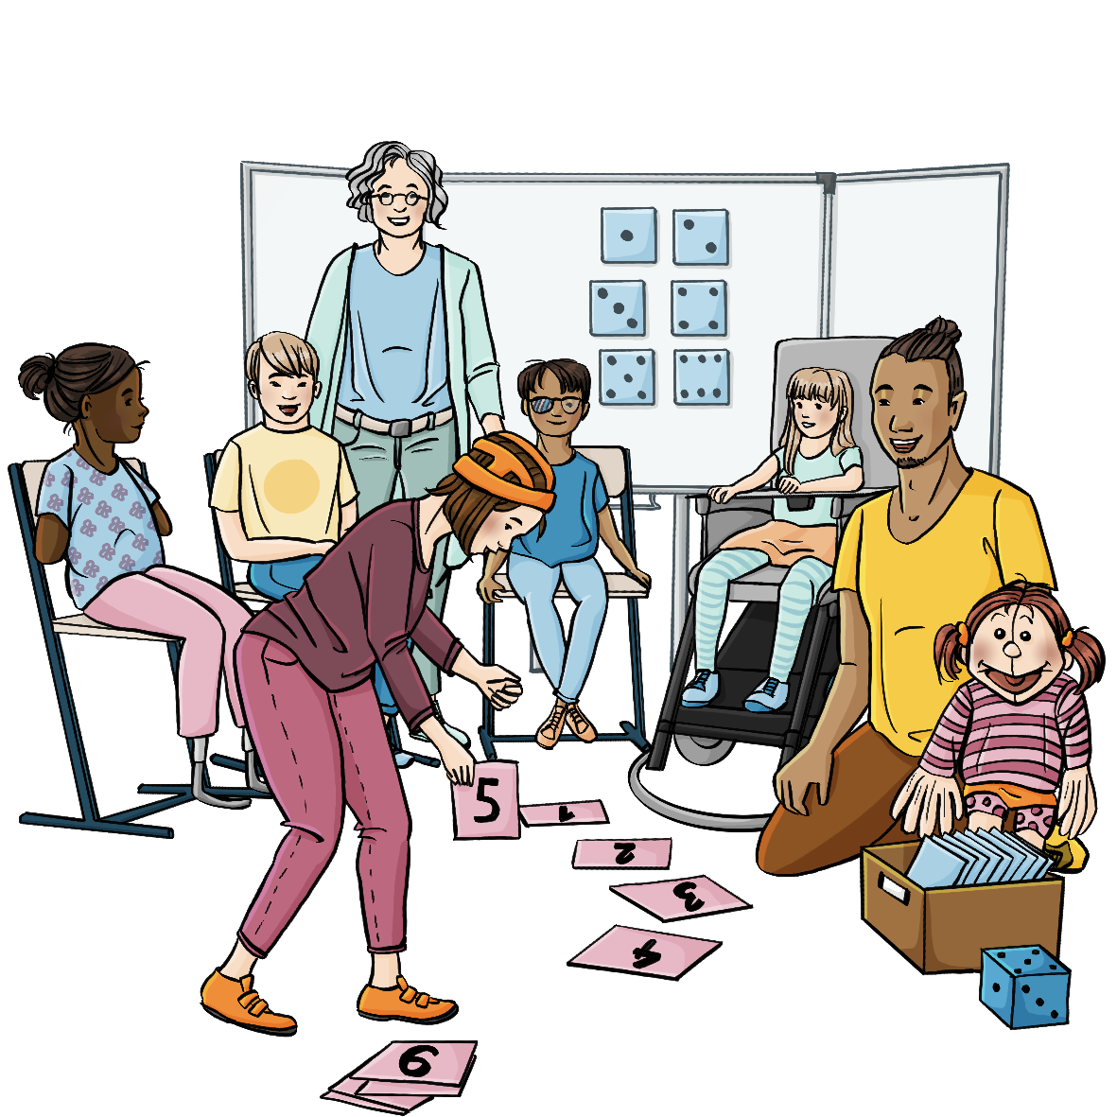
in a care home / a home where a group of children are cared for by us.


Te Mātātaki 2026 shows we are listening to what tamariki and rangatahi in care have to say.

About the survey


We want to thank everyone who took part in the survey.
We also know there are some people who did not want to / could not take part in the survey.


What you think:
is important to us
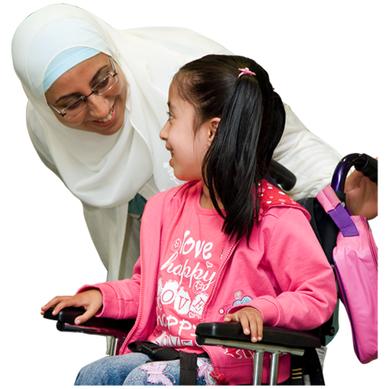
will support us to make the experiences of tamariki and rangatahi in care better.



The survey ran from
September 2024 to May 2025.


Who took part?

Almost half of the tamariki and rangatahi aged 10 to 17 years old in our care were asked if they wanted to do the survey.


Over 9 hundred of them chose to do the survey.

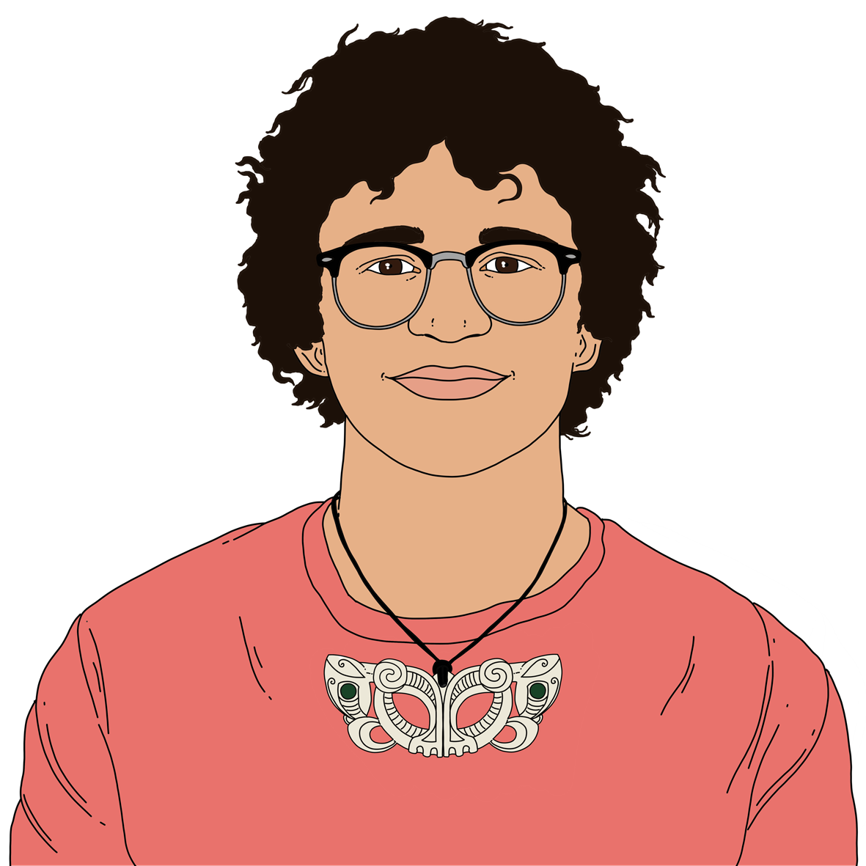
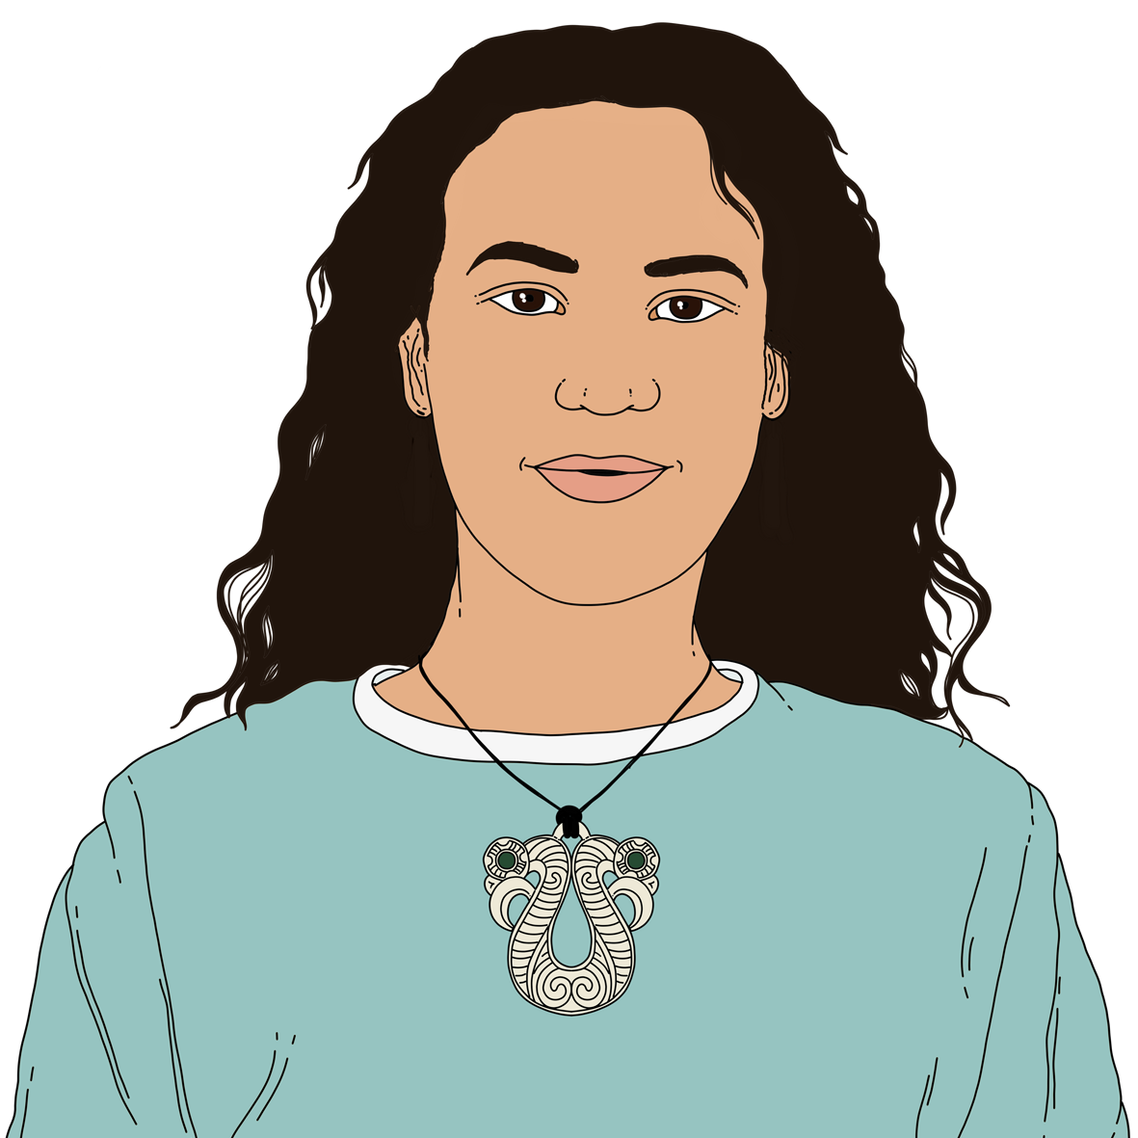
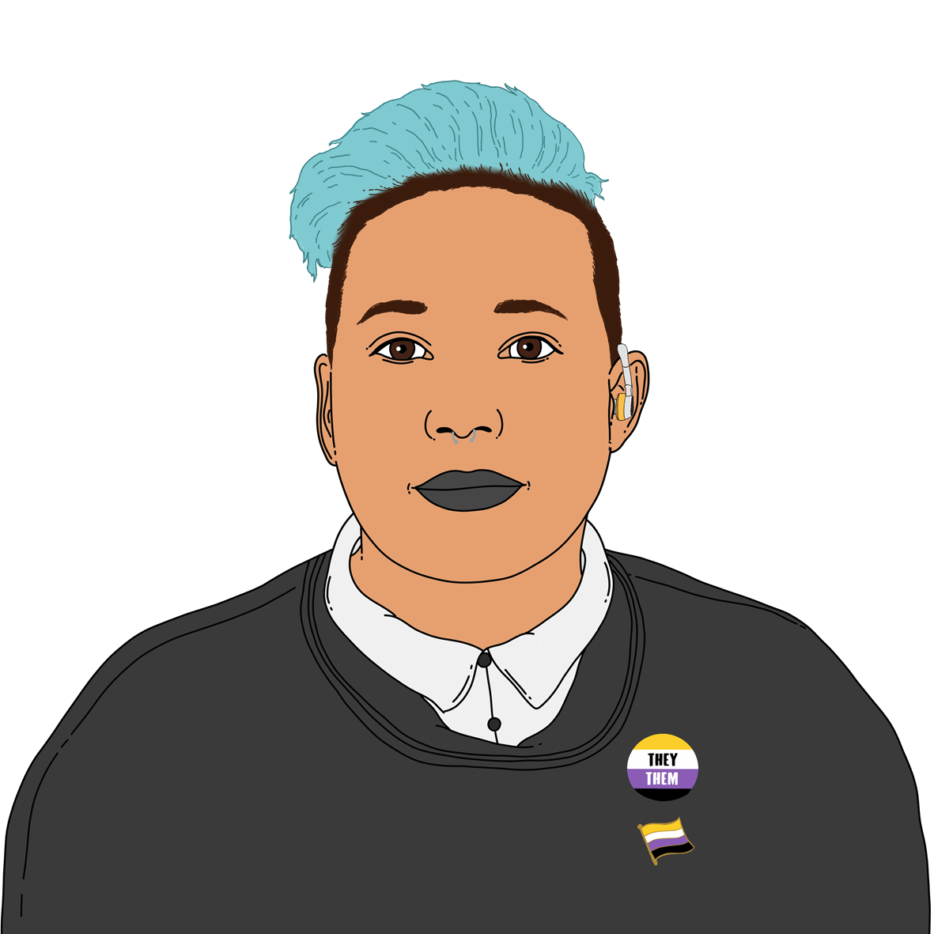
We heard from children and rangatahi who are:
male / men / boys
female / women / girls
another gender like non-binary.
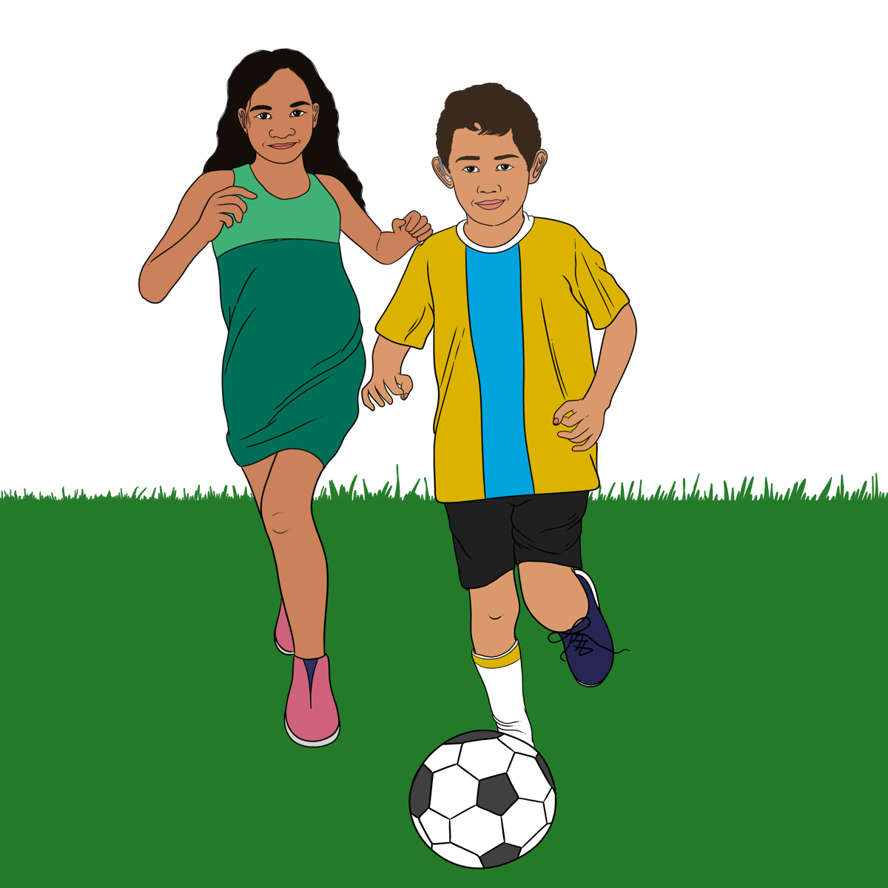

We heard from tamariki and rangatahi from lots of different ethnicities.
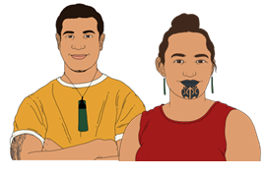
Ethnicity means your:
- race like:
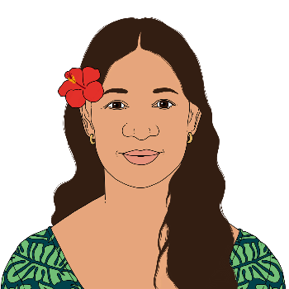
  - Māori
  - Samoan
  - New Zealand European
- background like whether you:
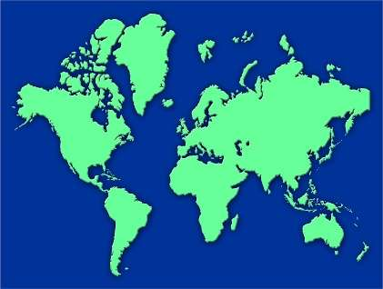
  - were born in Aotearoa New Zealand
- moved to Aotearoa New Zealand from another country.

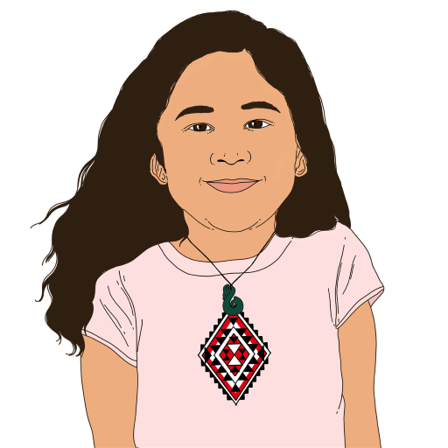
Some of the main ethnicities of the tamariki and rangatahi we heard from were:
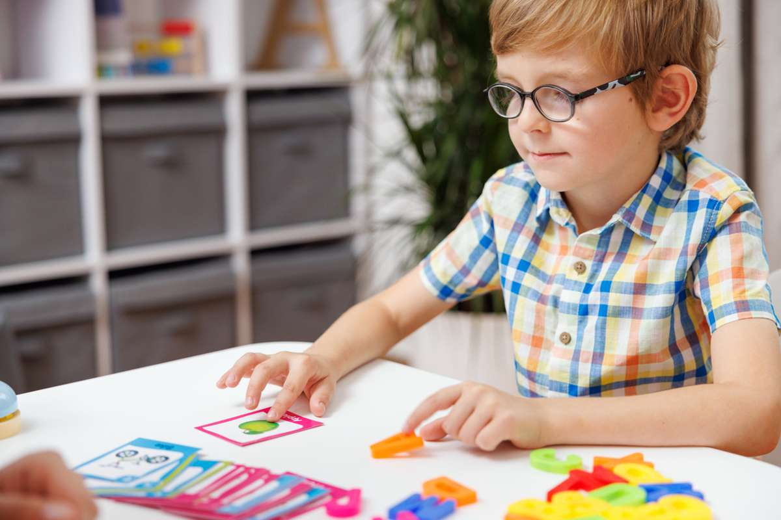
Māori
New Zealand European
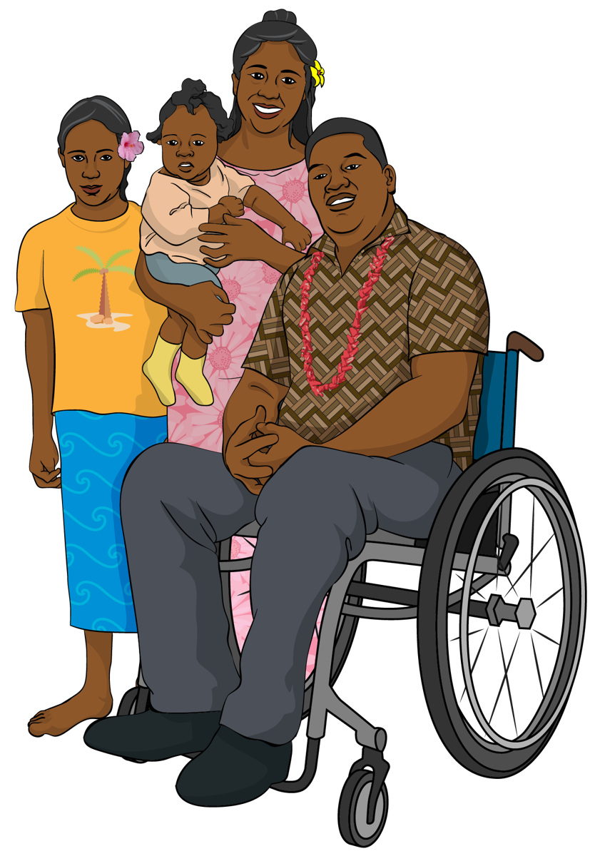
Samoan
Cook Islands Māori
Tongan.


About the questions

We ask the same questions every time we run the survey.
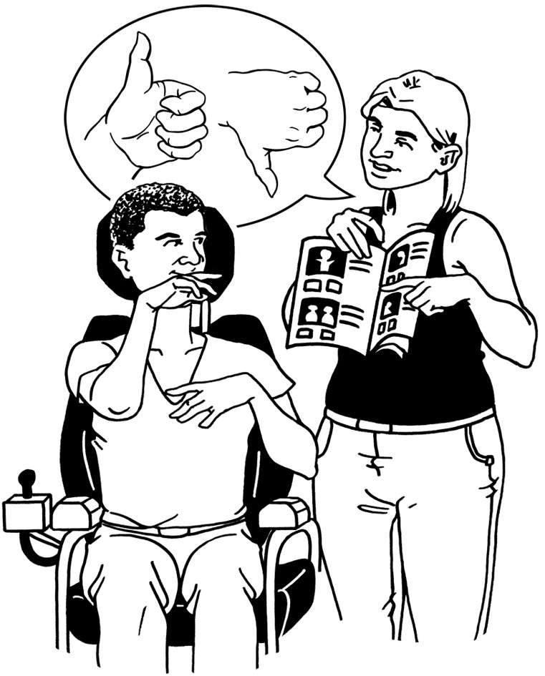

This means we can see if things are getting better.

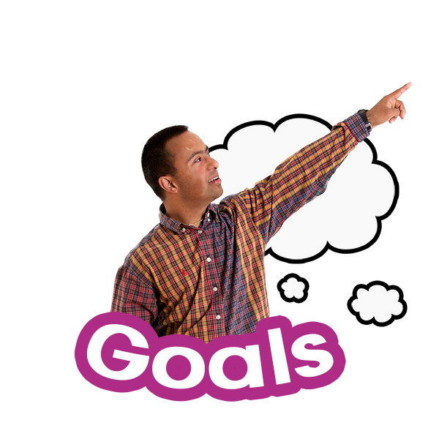
We added new questions to the survey in year 3 about:
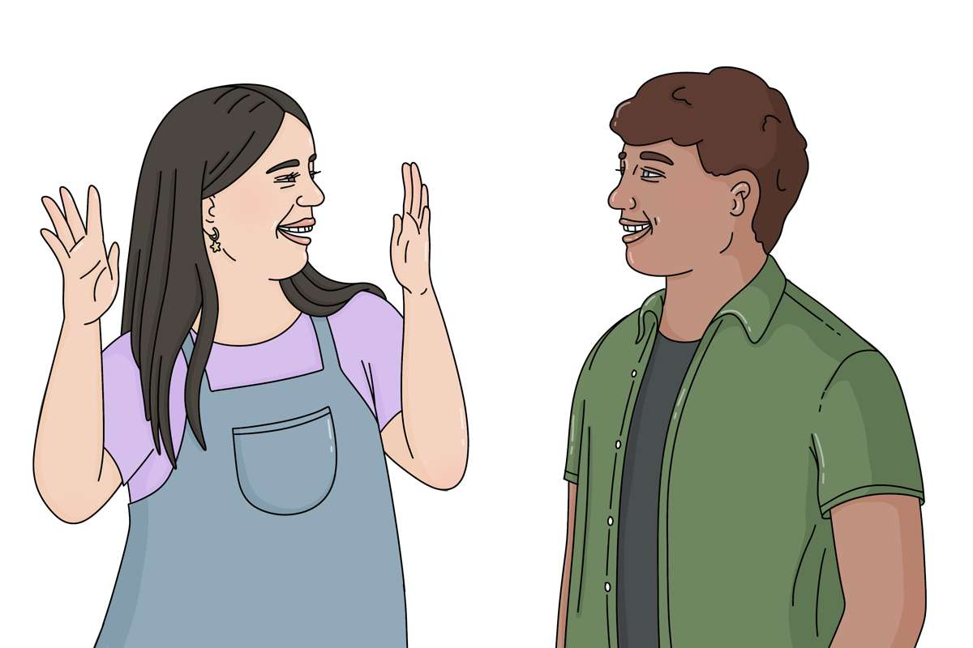
goals / what tamariki and rangatahi want to do
identity / how tamariki and rangatahi see themselves
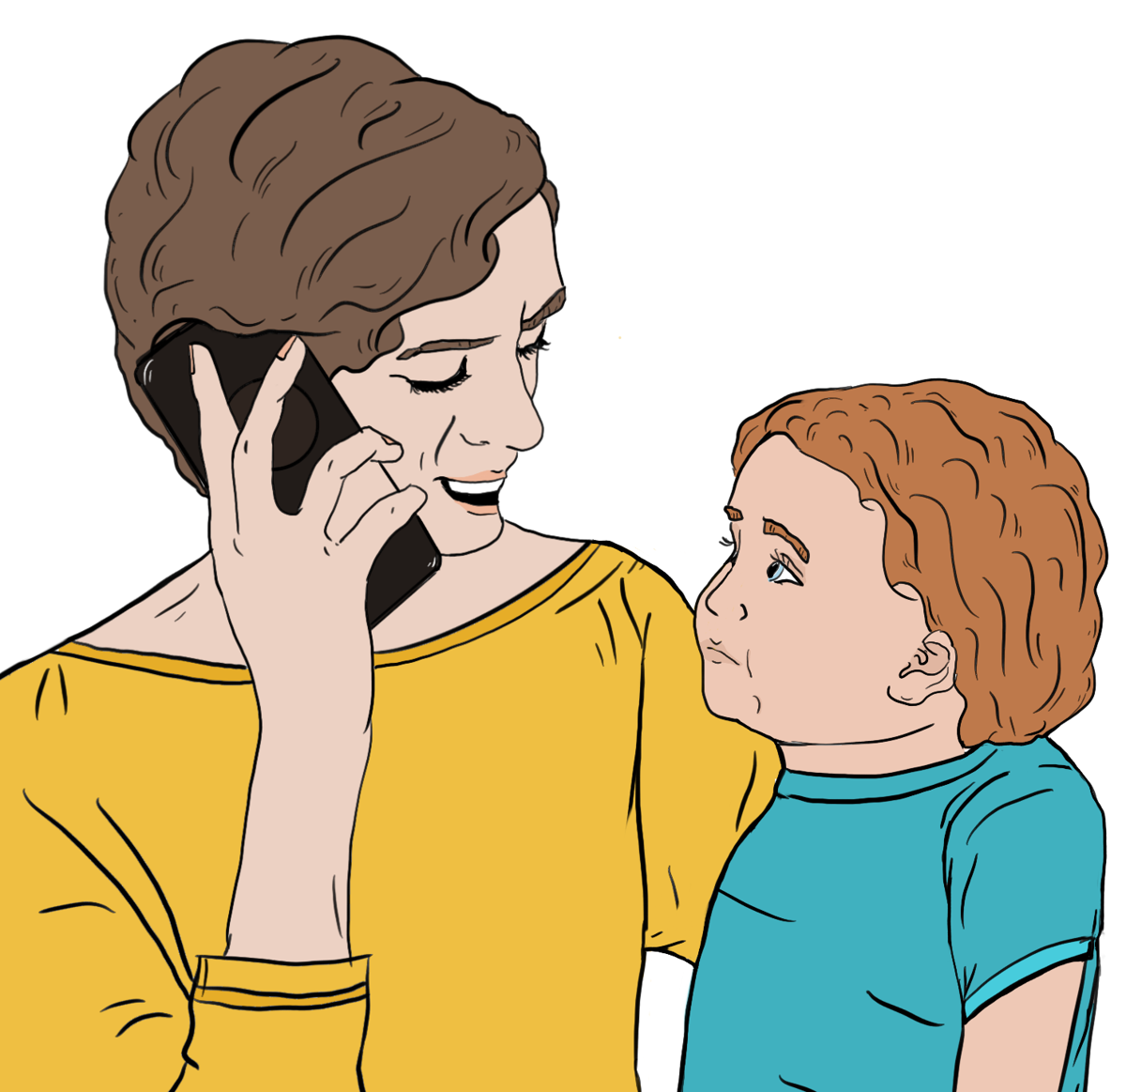
safety.

We also had 2 places in the survey where tamariki and rangatahi could add their answer in their own words.


We made sure it was safe for tamariki and rangatahi to share what they really think.

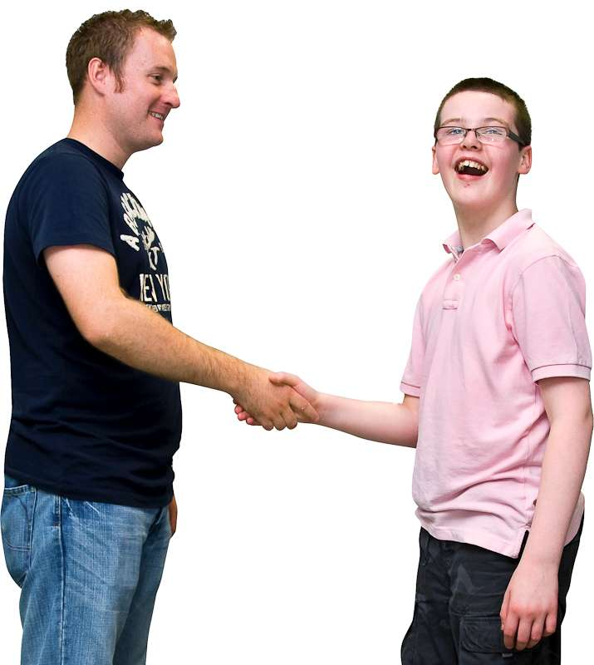
Any answers in the survey that showed someone might not be safe were followed up / checked on.

What tamariki and rangatahi told us


A lot of what tamariki and rangatahi told us was similar to what we found out in the last 2 surveys.


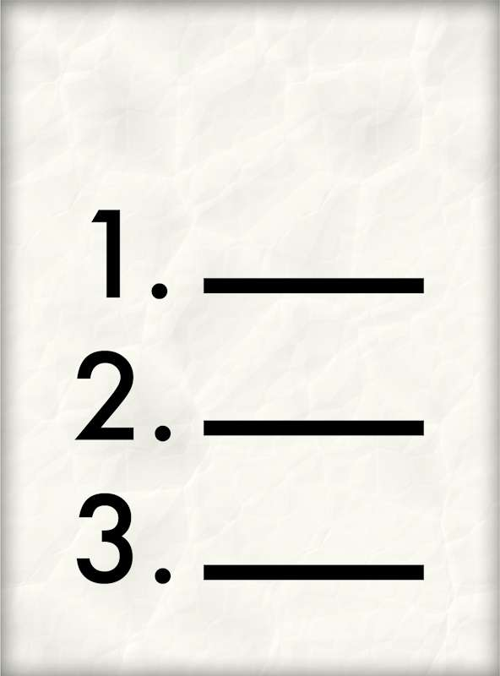
Similar means something is like something else but it is not the same.
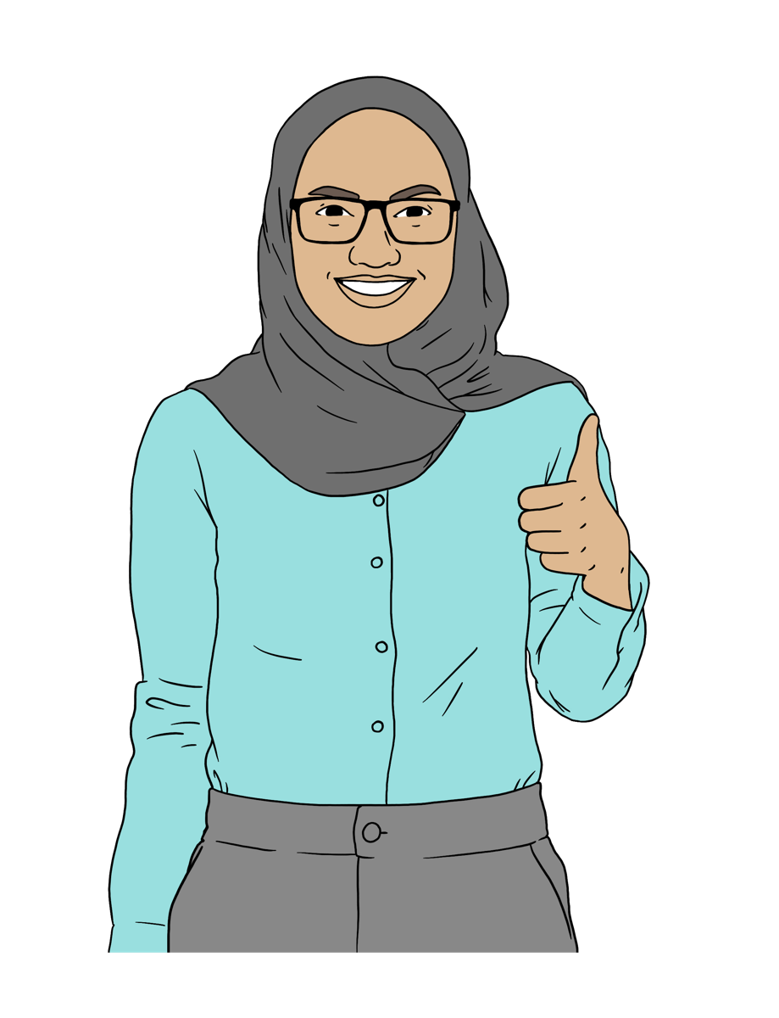

There were more positive / happy answers to some of the questions compared to the last 2 surveys.



Compared means to look at the differences between 2 things.

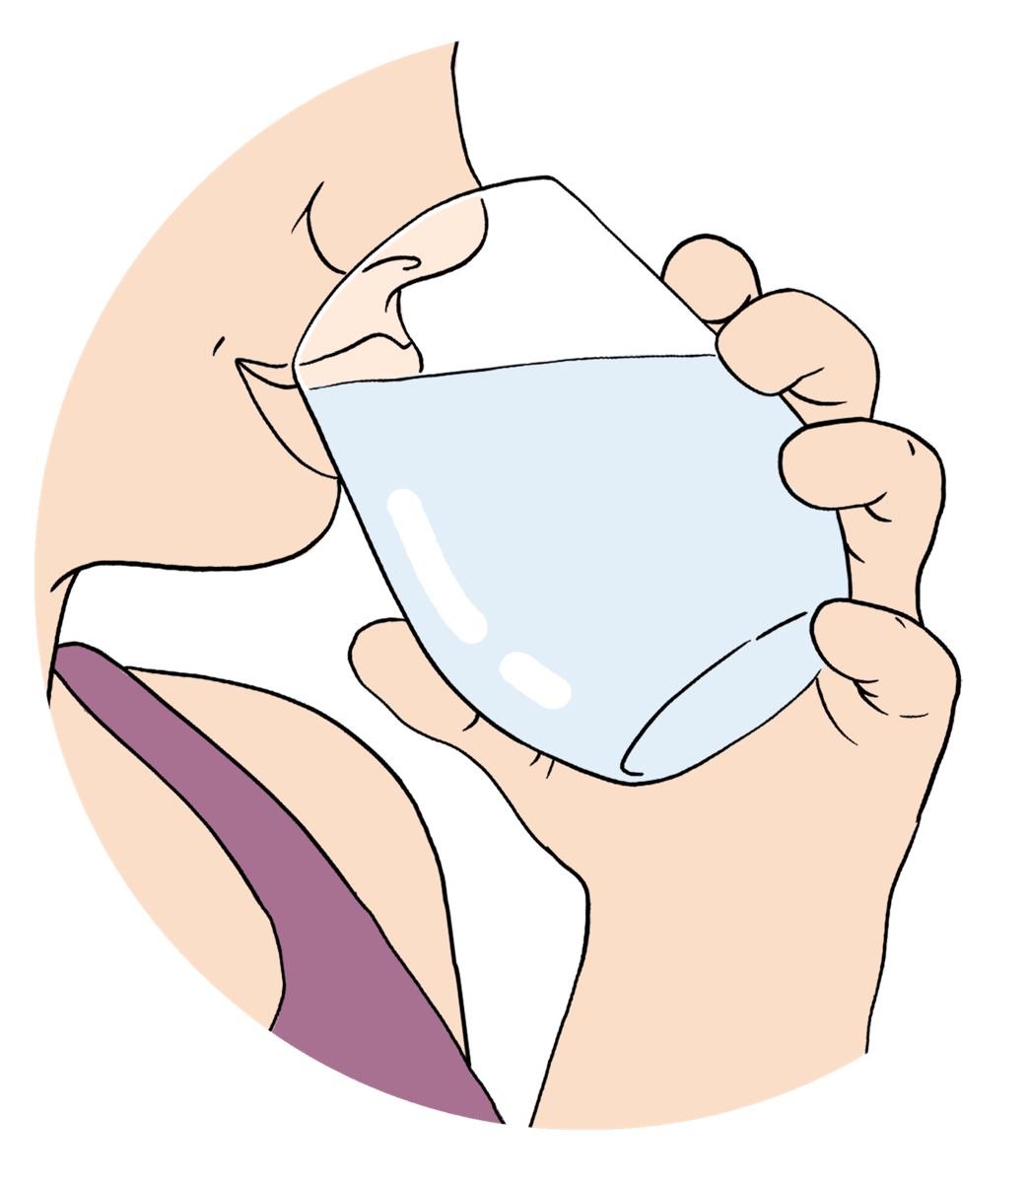
For example you might drink more water today compared to how much water you drank yesterday.
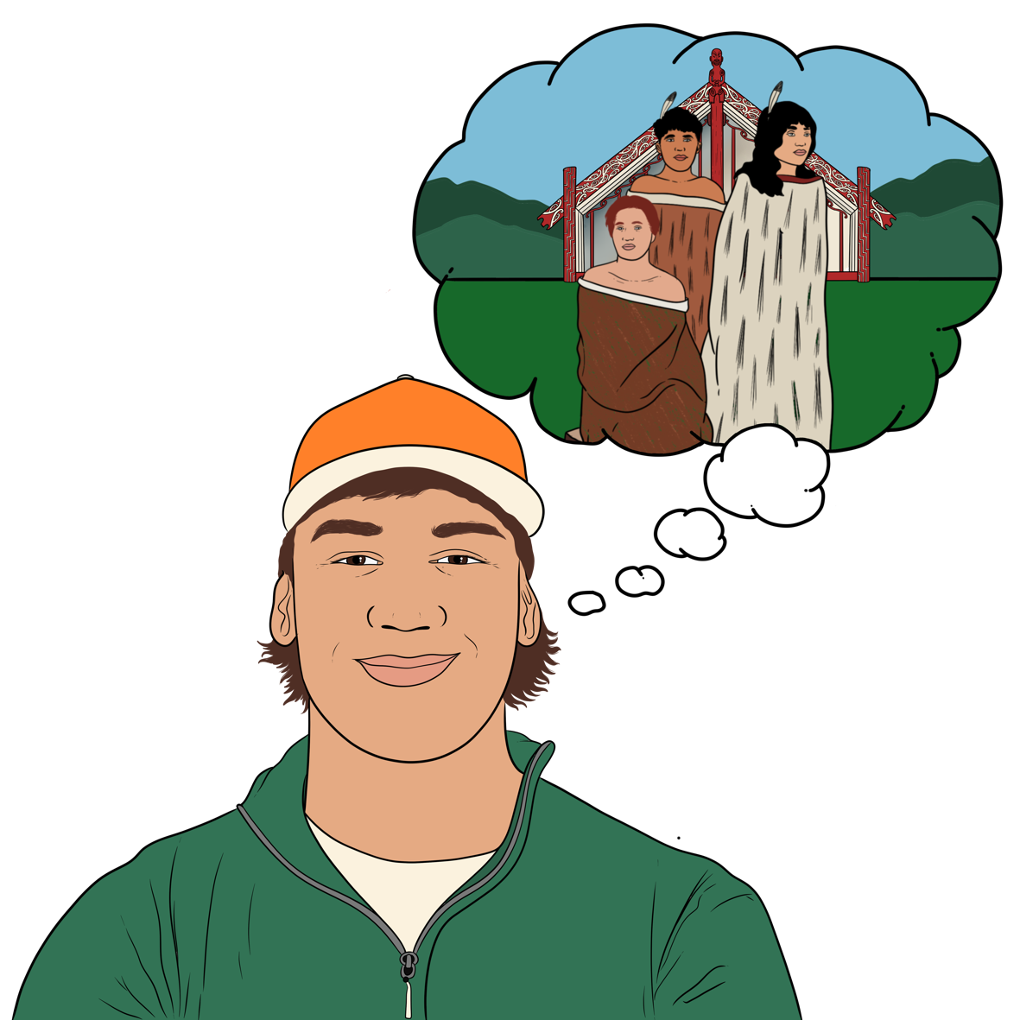
Compared to year 2 of the survey there were more positive answers about tamariki and rangatahi:
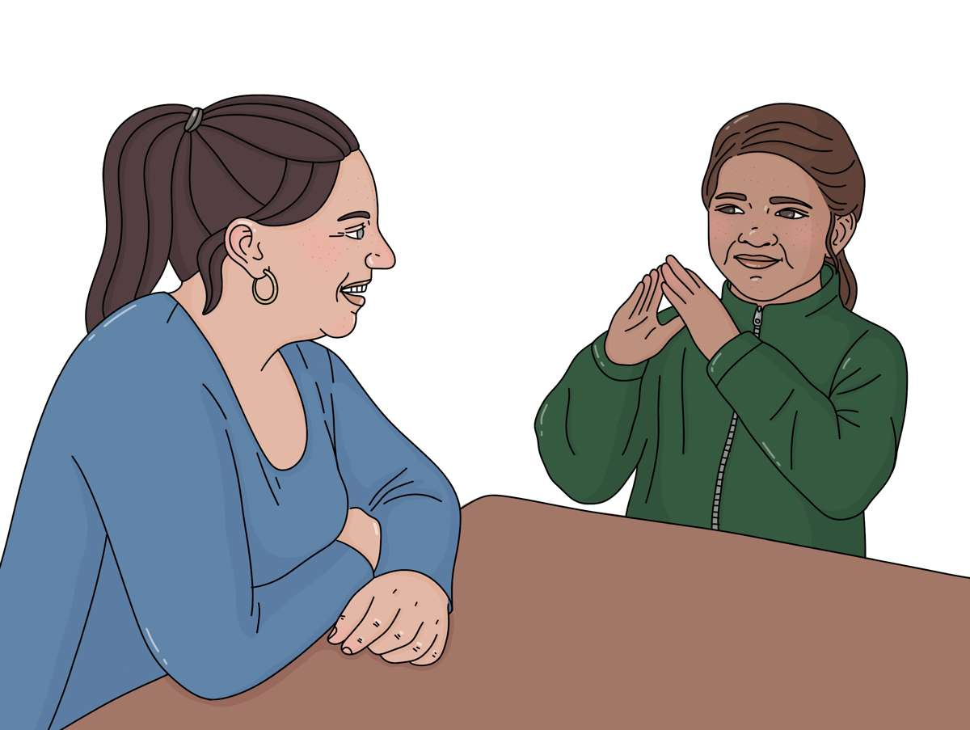
knowing their whakapapa / ancestry
feeling they could talk to their social worker.
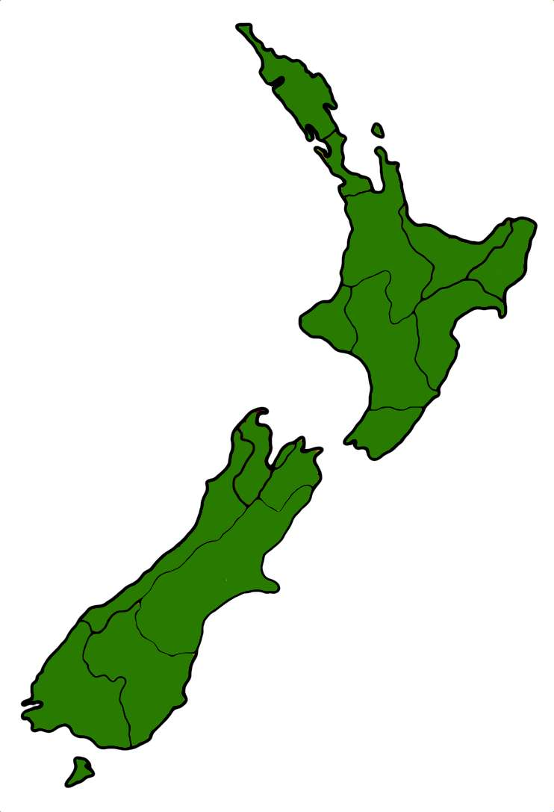

Whakapapa / ancestry is about knowing your tupuna / ancestors.

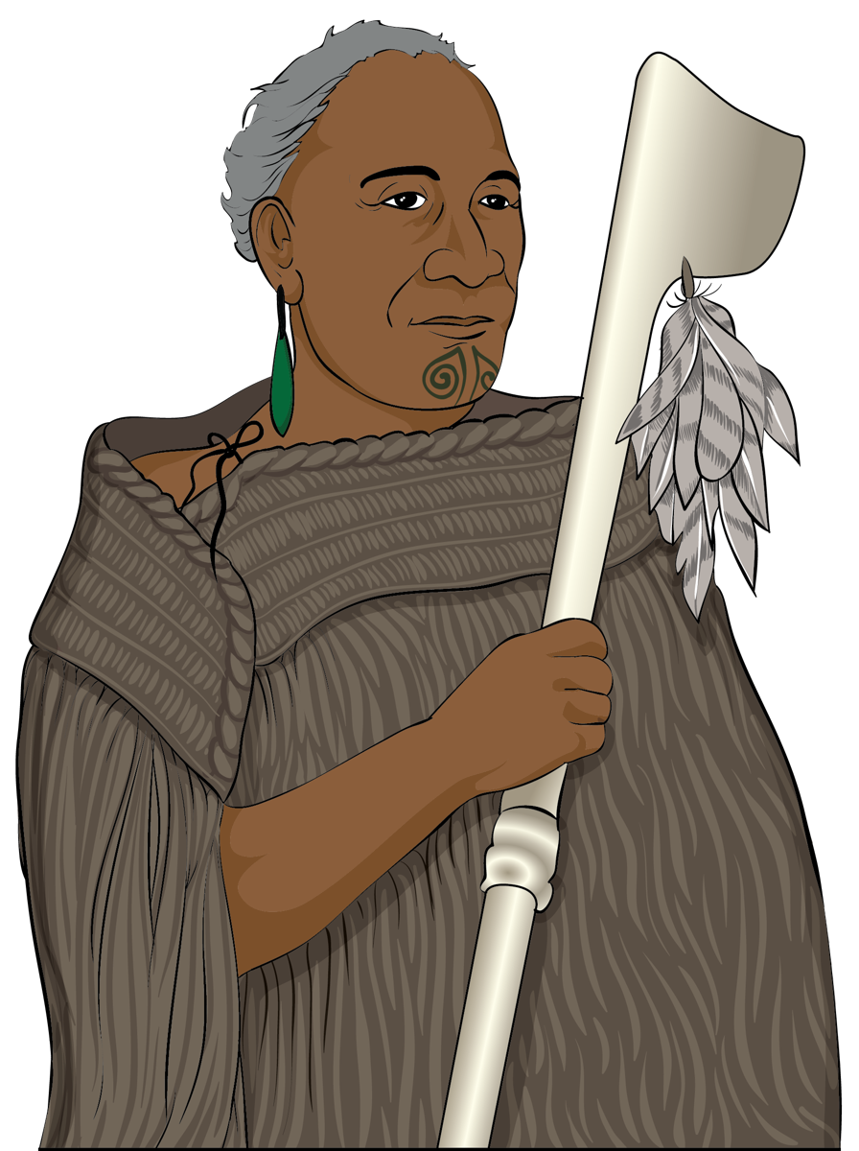
Tupuna / ancestors are the people in your family who have lived before you.

Here a social worker is someone who:

works for Oranga Tamariki
supports tamariki and rangatahi in care.

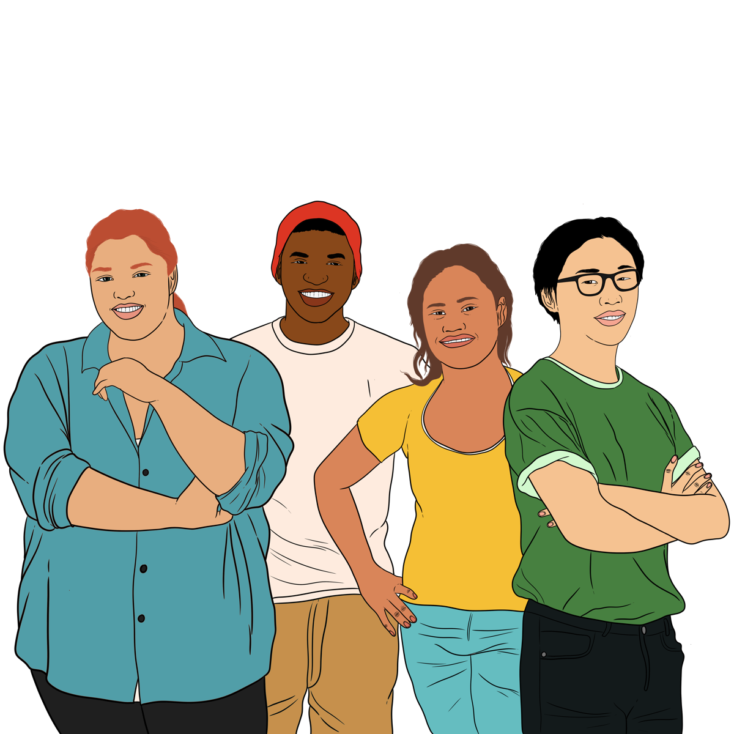
Compared to year 1 of the survey there were more positive answers for tamariki and rangatahi:
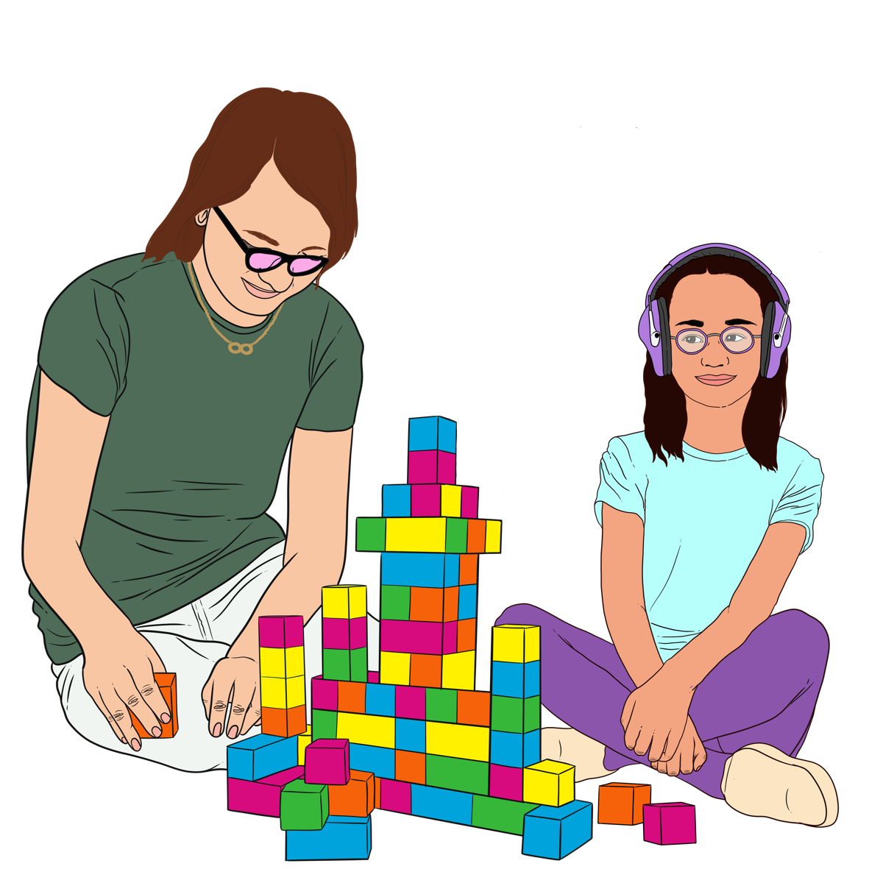
feeling accepted for who they are
keeping in touch with
whānau / family as much as they wanted
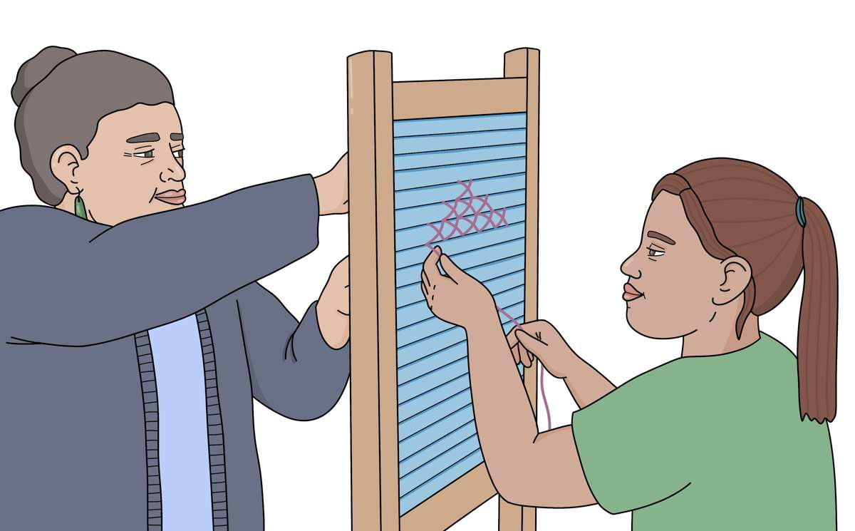
having friends they could talk to
having chances to learn about their culture.

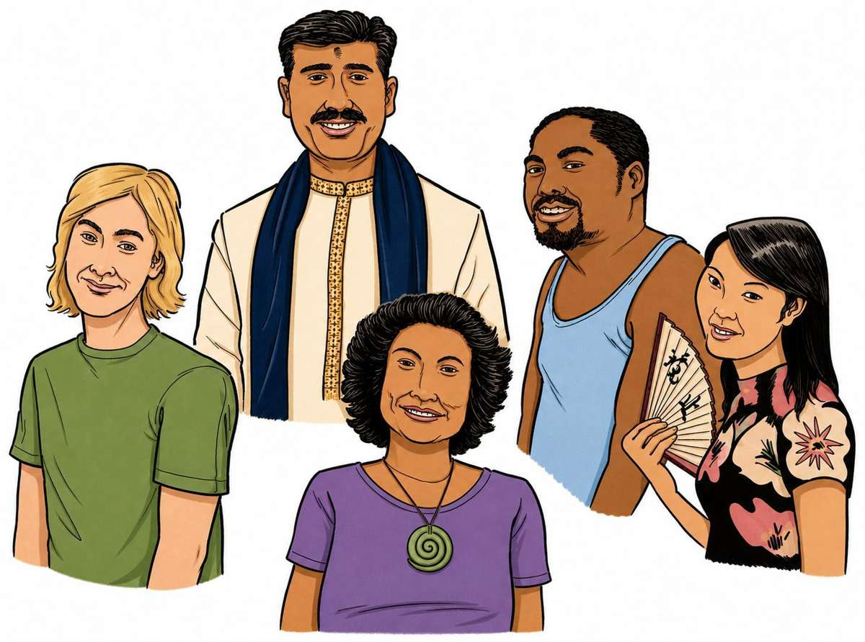
Culture is a way of:
thinking that a group shares
doing things as a group.
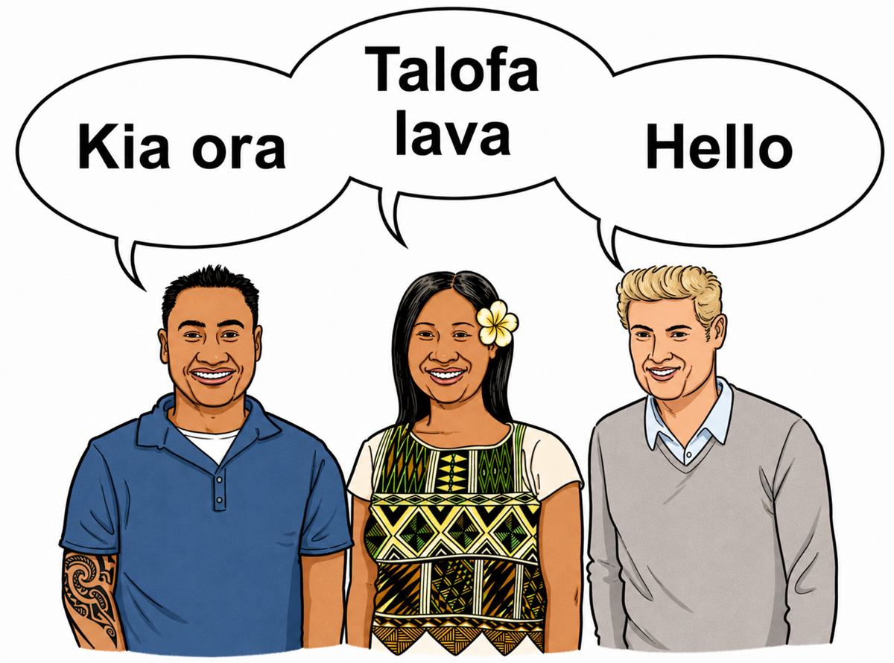

There are many different cultures in
Aotearoa New Zealand.
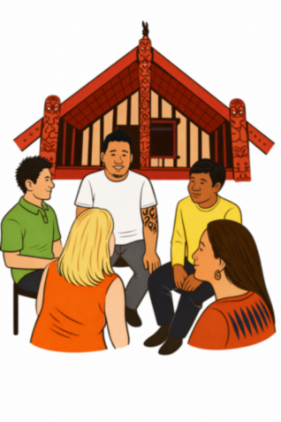

Some examples of the different cultures are:
Māori culture
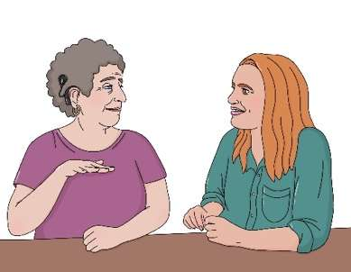
Pacific culture
Deaf culture.

Experiences of being in care

Tamariki and rangatahi were asked questions about their experience of being in care.

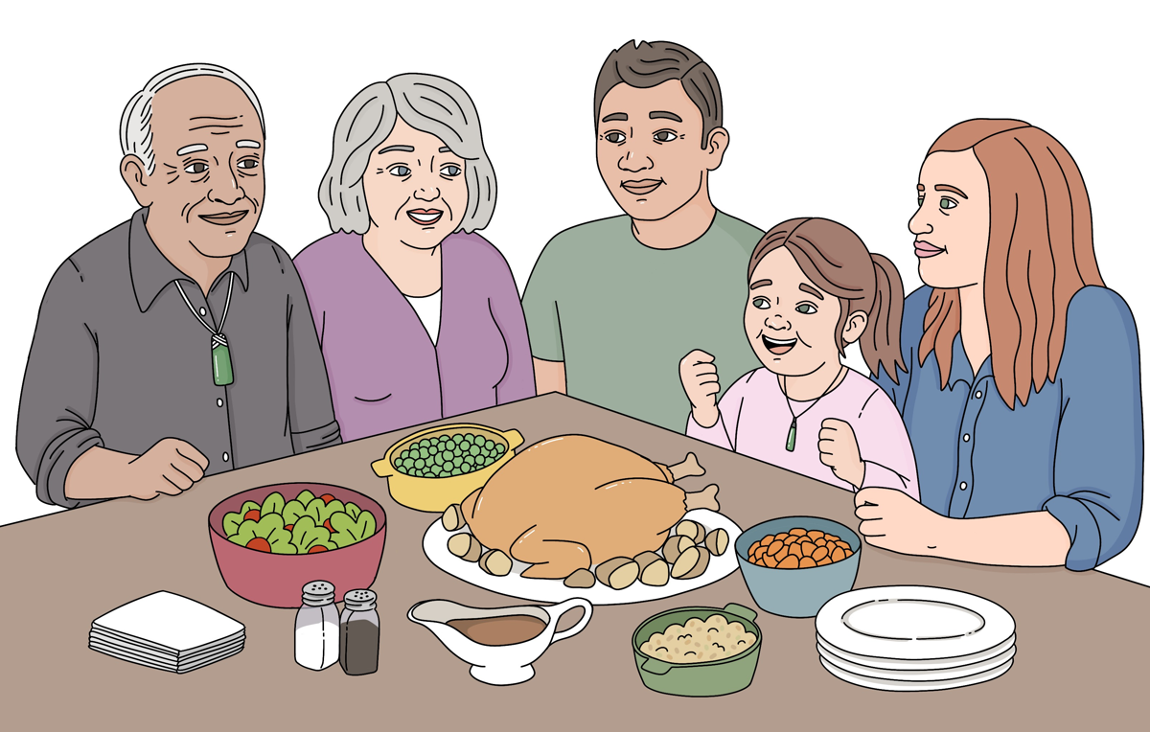
Most tamariki and rangatahi said:
the adults they lived with looked after them well all the time

they felt safe where they lived.

Many tamariki and rangatahi said:
they had people in their life that loved them no matter what
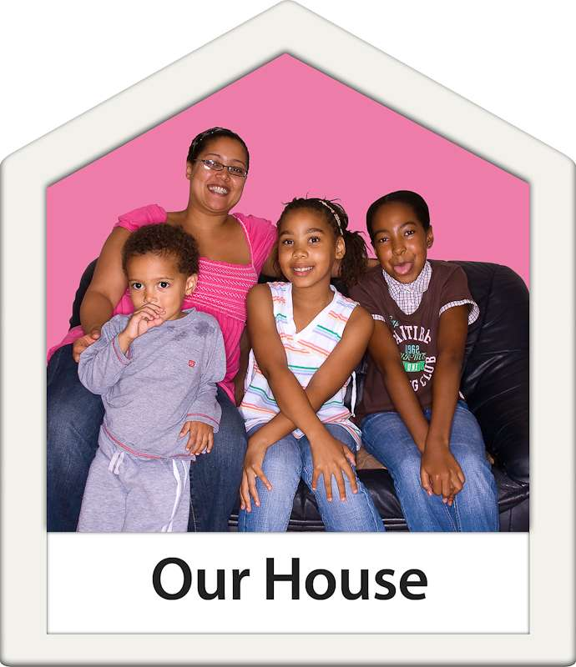
the adults they lived with accepted them for who they are
they felt settled where they lived.

Here settled means feeling you are:
comfortable
relaxed.
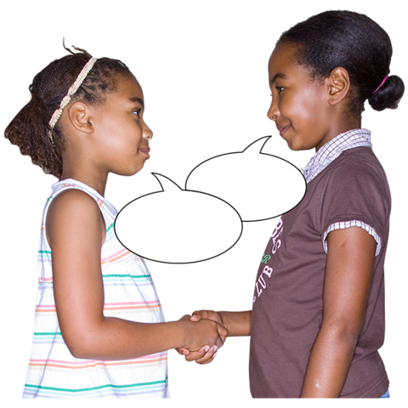

Many tamariki and rangatahi said:

they had a friend / friends they could talk to about anything
they had somewhere they felt they belonged.


Around half the tamariki and rangatahi said they:
felt supported to reach their goals
got to keep in touch with the
whānau / family they were born into as much as they wanted

Around half the tamariki and rangatahi said they found it easy to express their identity.

Here identity is what makes you who you are like:
your ethnicity

your language
what you like / do not like
the clothes you like to wear.
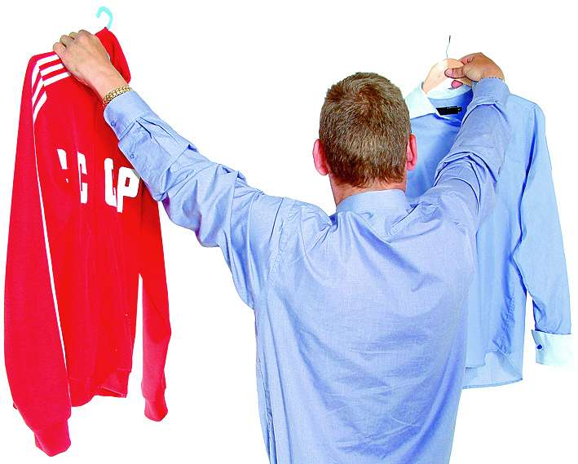

Identity means different things to different people.

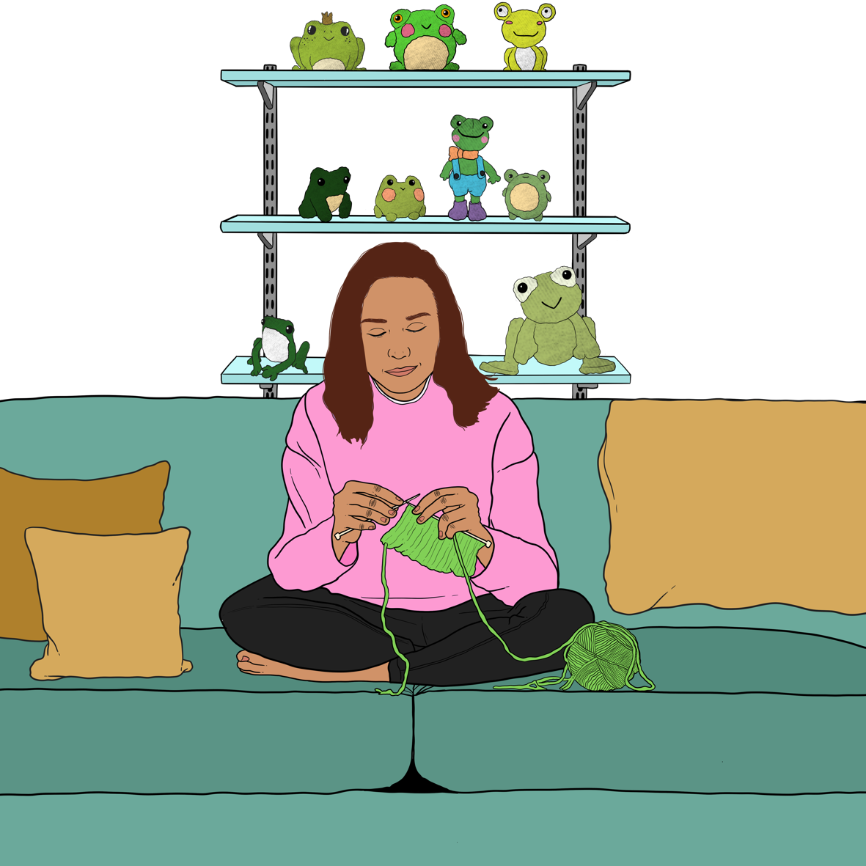
Expressing your identity means all the ways you show who you are.
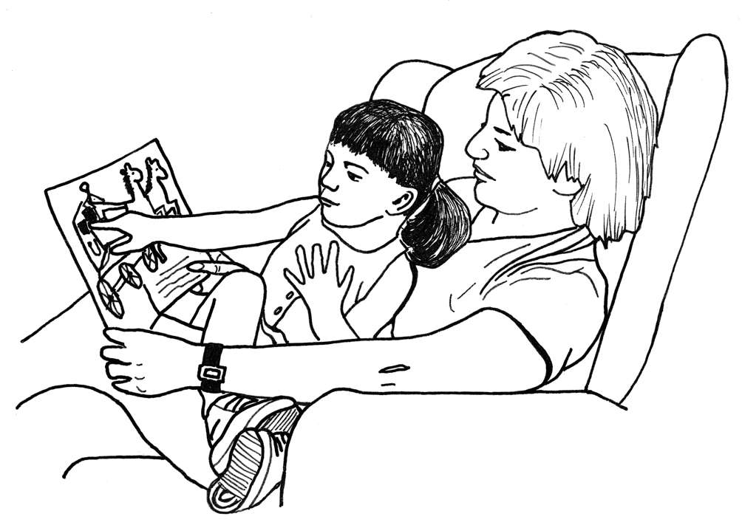
Around half the tamariki and rangatahi said they got the chance to learn about their culture.


Some tamariki and rangatahi:
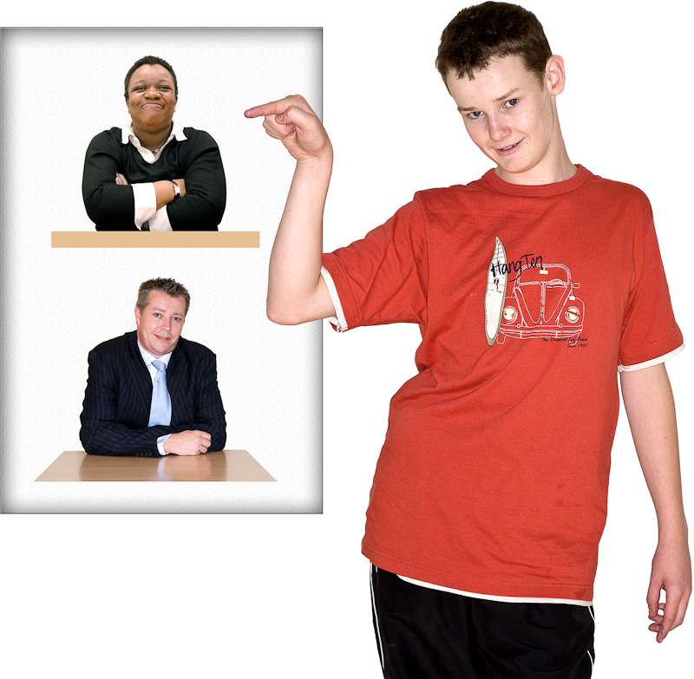
thought they would have a good life when they got older
said they got to have a say in decisions about their life all the time
said they knew their
whakapapa / family history.

The role of Oranga Tamariki

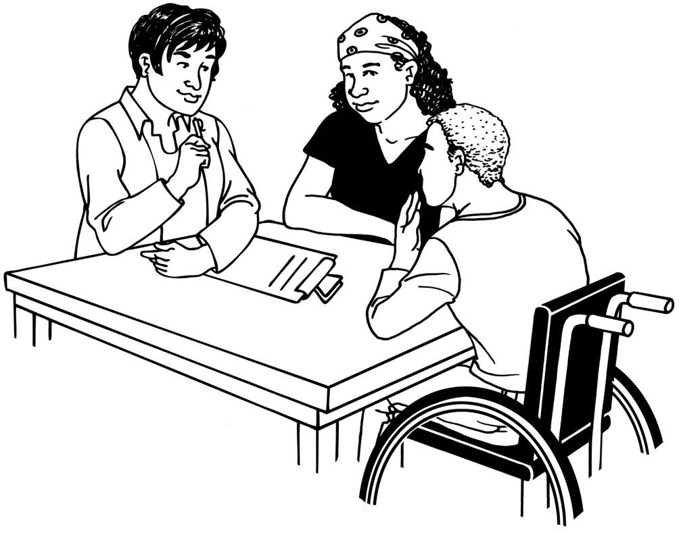
Tamariki and rangatahi were asked questions about:
how they got along with their social worker
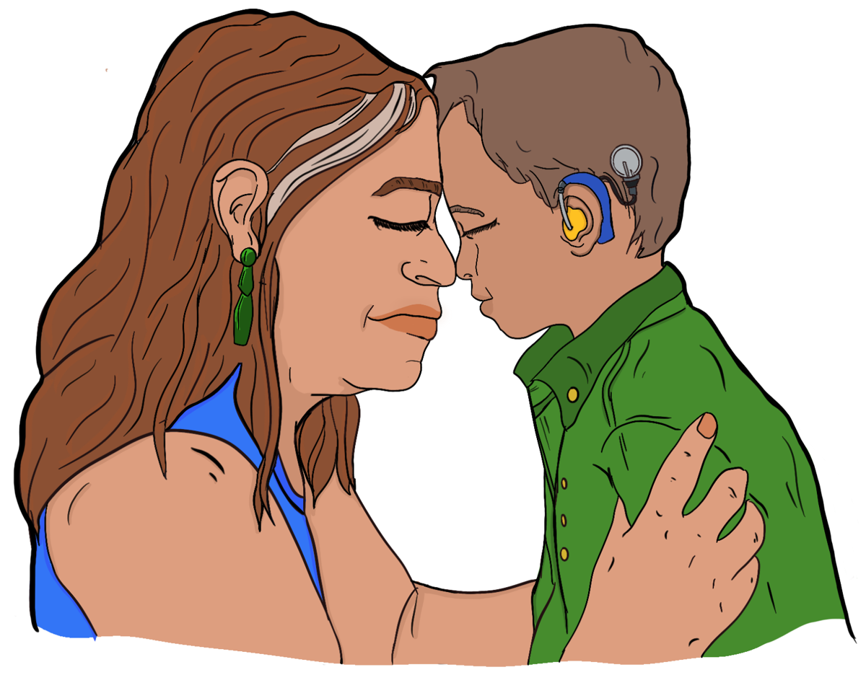
if they felt Oranga Tamariki made things better for them.

Around half the tamariki and rangatahi said:
they felt they could talk to their social worker about their worries
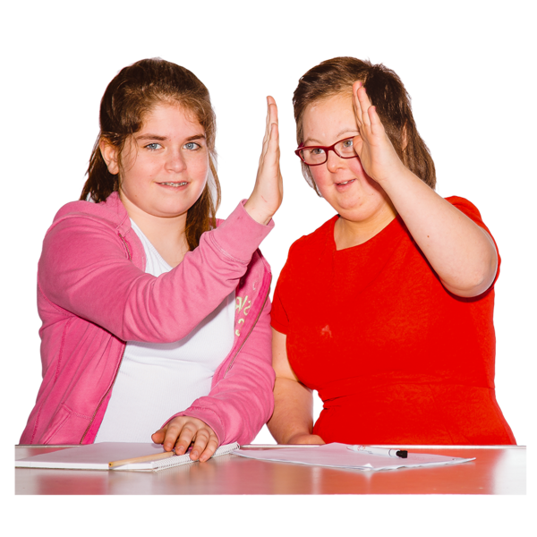
their social worker did what they said they would do all the time.

Some tamariki and rangatahi said Oranga Tamariki made things better for them.

Differences across tamariki and rangatahi

We found sometimes the answers were similar from groups that were the same:
age
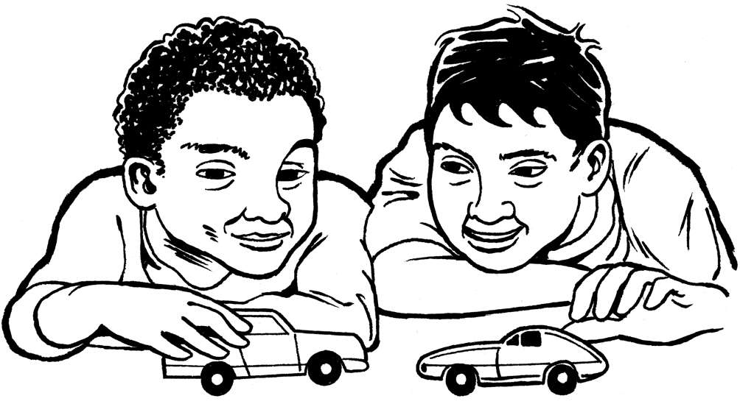
gender
ethnicity.

We found that older tamariki and rangatahi were more likely than younger tamariki and rangatahi to say they got to:
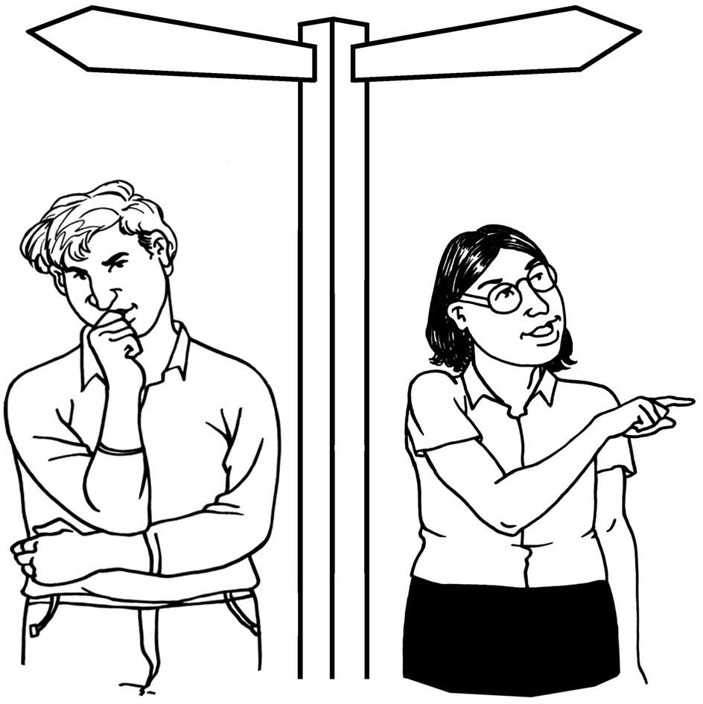
have a say in important choices about their life
learn about their culture.

We found that older tamariki and rangatahi were more likely than younger tamariki and rangatahi to say:

they got to keep in touch with the whānau / family they were born into as much as they liked
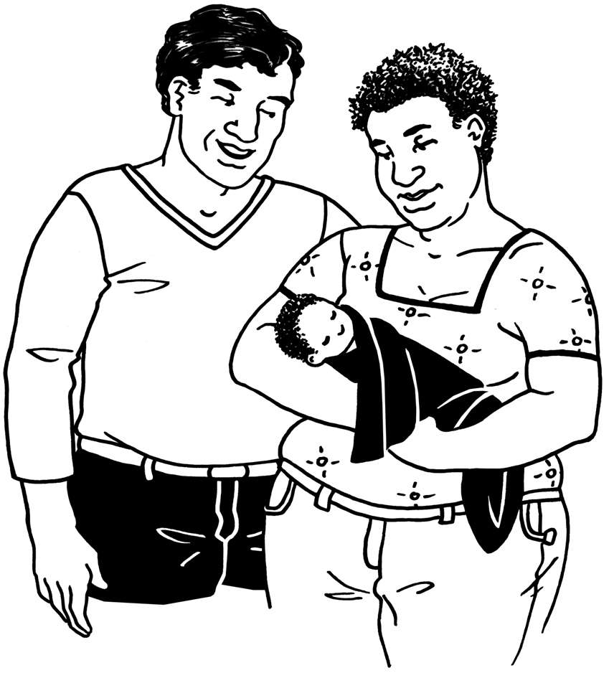
they did not want to keep in touch with the whānau / family they were born into.

We found that younger tamariki and rangatahi were more likely than older tamariki and rangatahi to say that Oranga Tamariki made things better for them.


We found that boys were more likely than girls to say that Oranga Tamariki made things better for them.

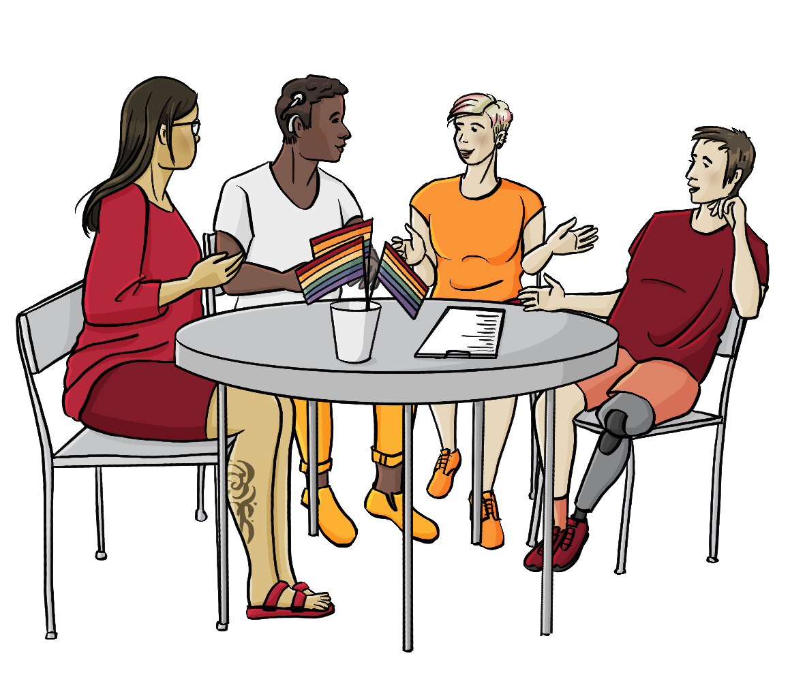
Only a small number of tamariki and rangatahi said they were another gender.

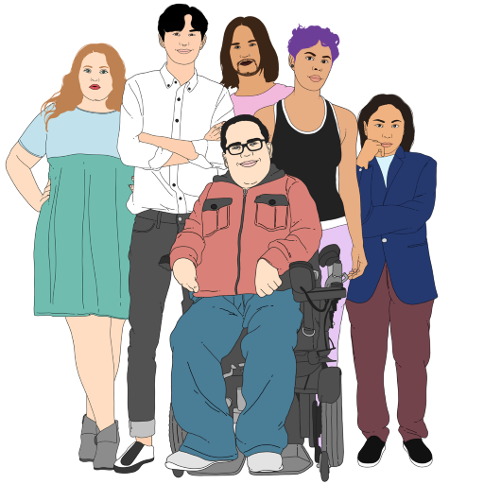
Another gender means someone is not a:
boy / man
girl / woman.

Another gender can be any other gender like:
non-binary
transgender.


Because they were only a small number it was hard to find out much from what they said.


We noticed that many of these tamariki and rangatahi gave answers that were negative / not saying good things.

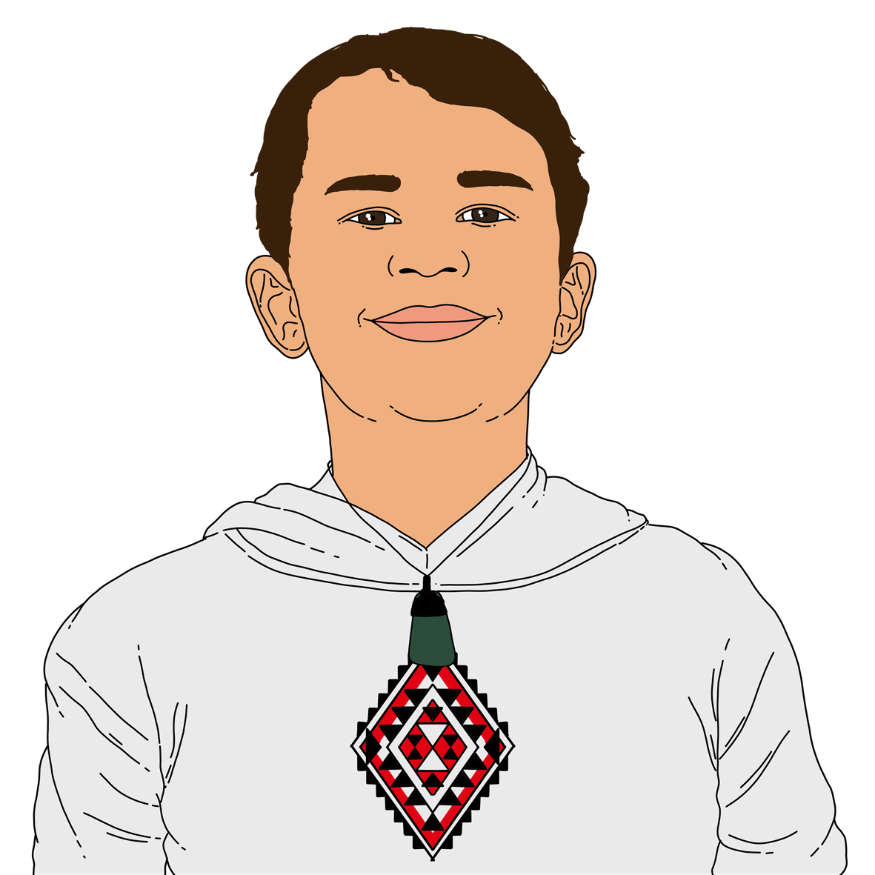
Tamariki and rangatahi who were more likely to say they got the chance to learn about their culture were:
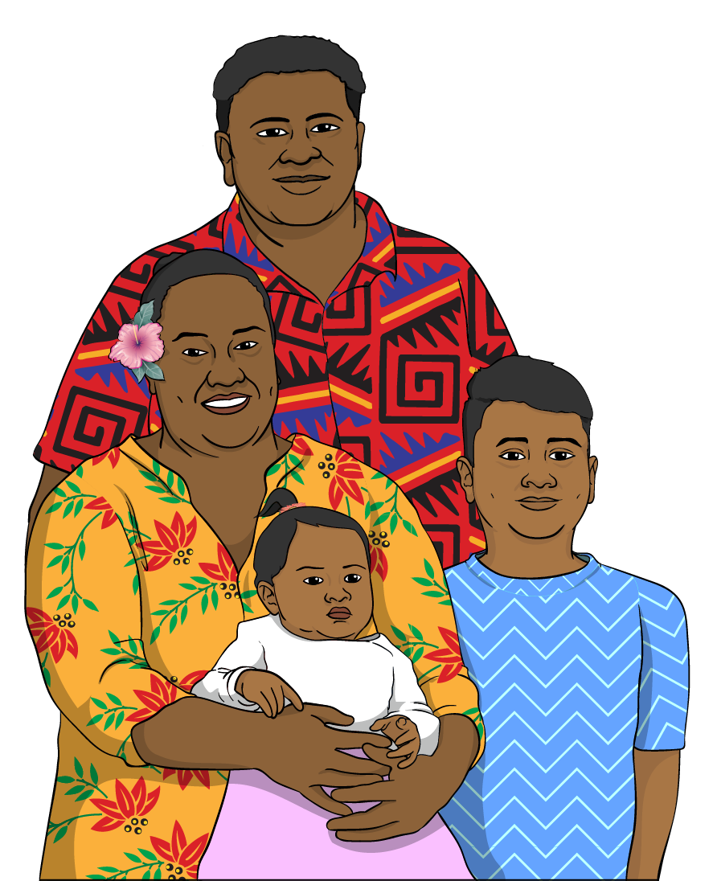
Māori
Pacific peoples.

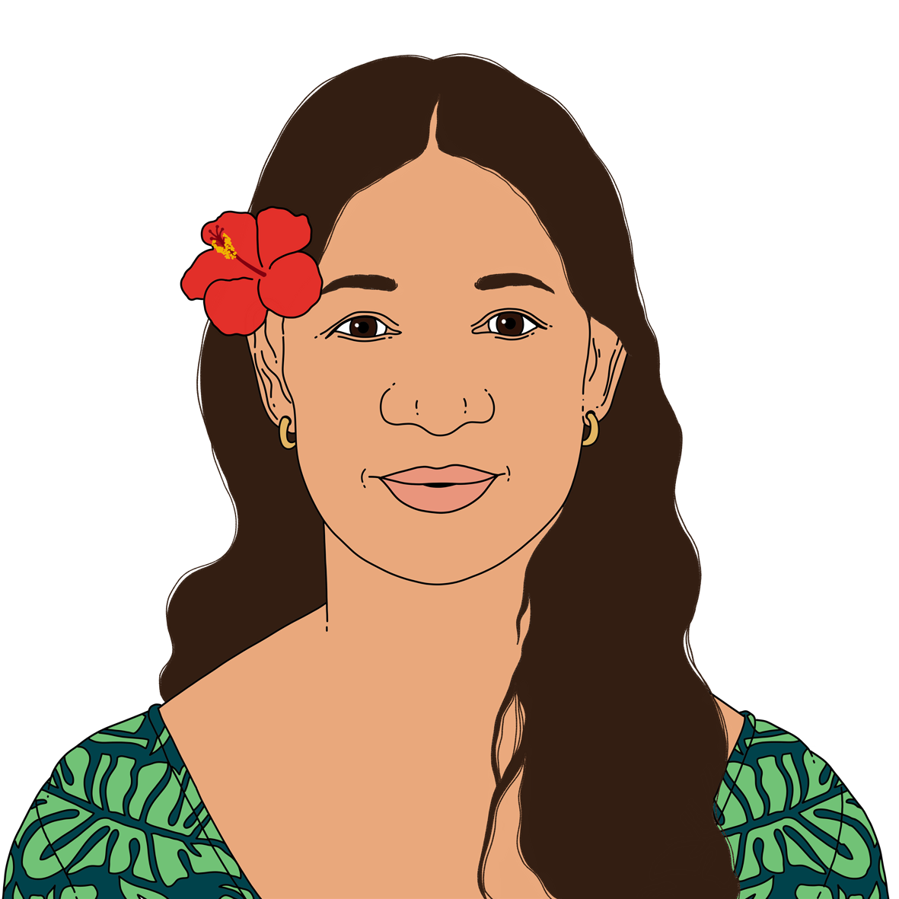
Tamariki and rangatahi who had at least 1 Pacific ethnicity were more likely to say Oranga Tamariki made things better for them.

In their own words

We added some questions to this survey where tamariki and rangatahi could write what they wanted to tell us.

This part of the Easy Read will tell you what they said to each of those questions.


Do you feel safe where you live now?

2 out of every 10 tamariki and rangatahi who did the survey answered this question with their own thoughts.

They told us about things that made them feel safe.

Things that made them feel safe were living somewhere with no:
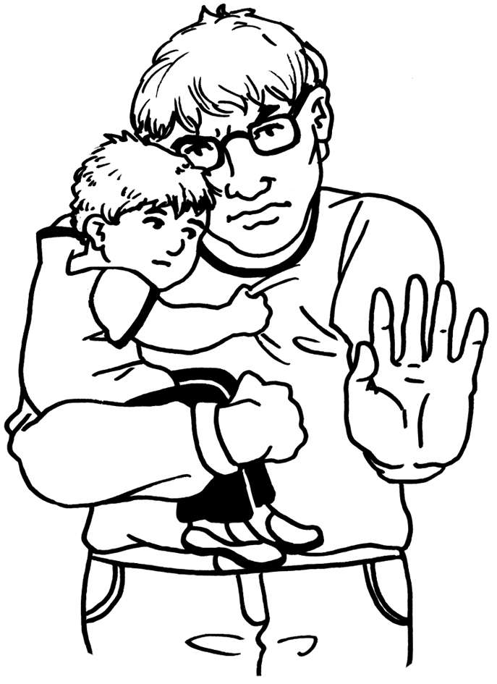
physical violence like being hit
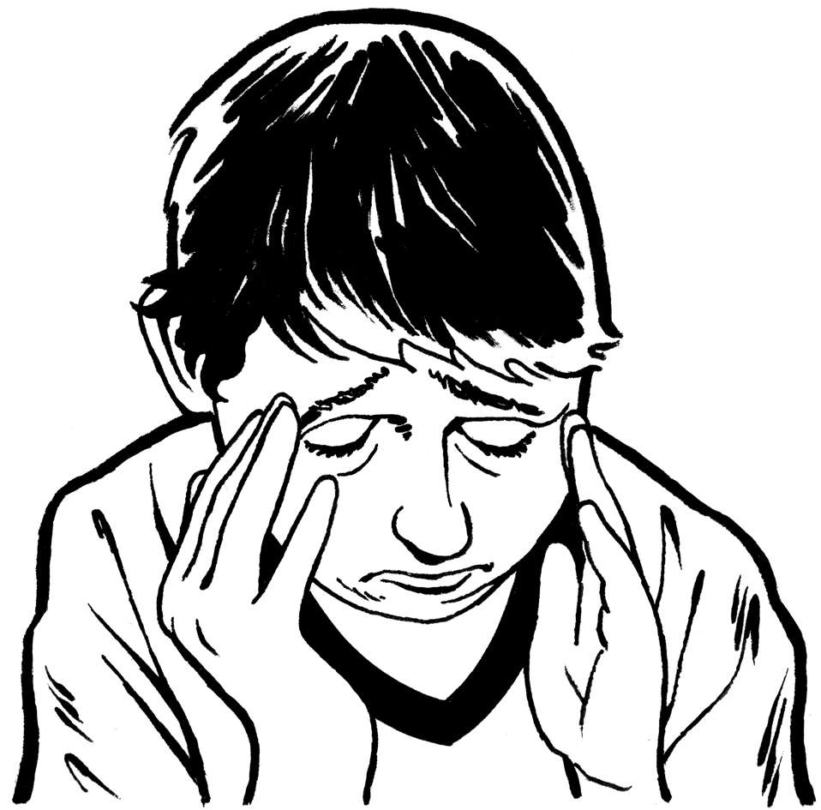
verbal abuse like being yelled at a lot
emotional harm like being made to feel bad about themselves.

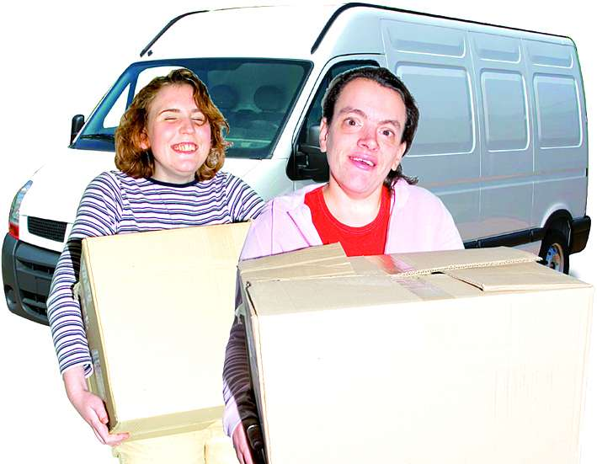
They also told us about things that made them feel unsafe like:
changing where they live a lot
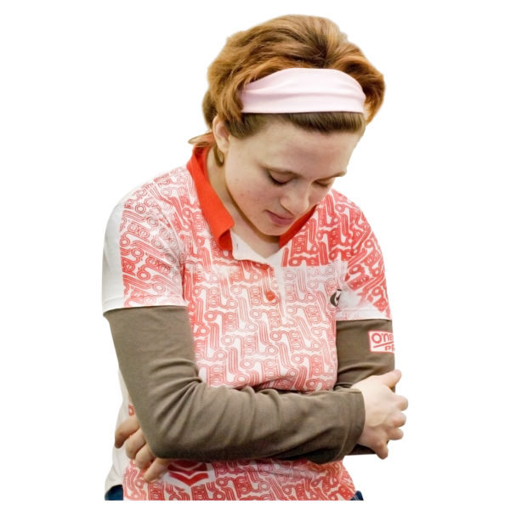
living somewhere for a short time
missing their whānau / family
not being accepted for who they are.

Is there anything else you would like to tell us?
2 out of every 10 tamariki and rangatahi who did the survey answered this question with their own thoughts.

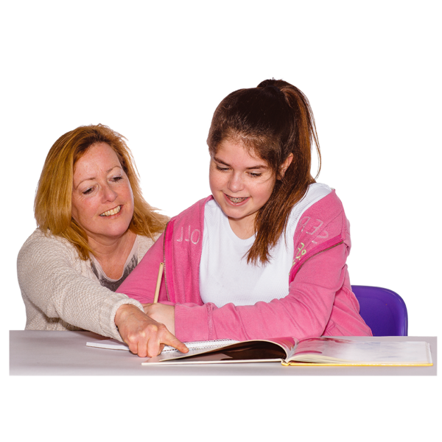
Many answers were about different experiences with social workers like:
being listened too
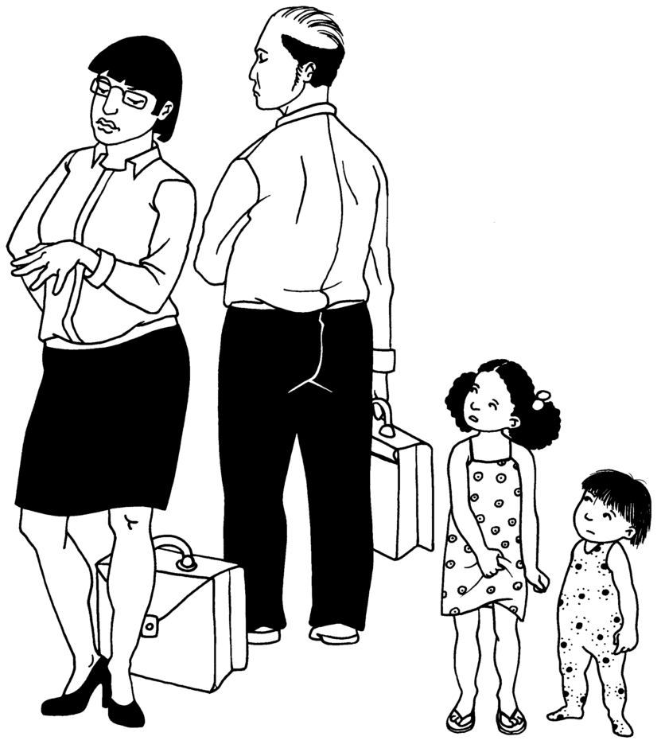
the social worker seemed too busy.


Tamariki and rangatahi also wanted to tell us about their rights to:
contact their whānau / family
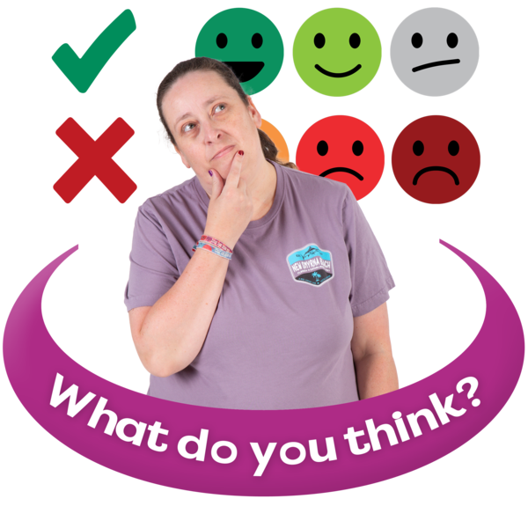
make complaints
tell us what they think.

Priority areas for action


We have created 4 priority areas for action to respond to what tamariki and rangatahi have told us.


Here priority areas means things
we will look at / do first.

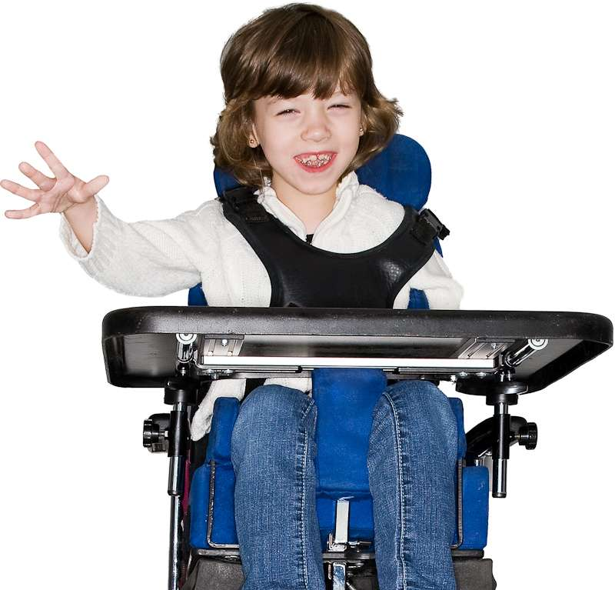
2 of the priority areas are:
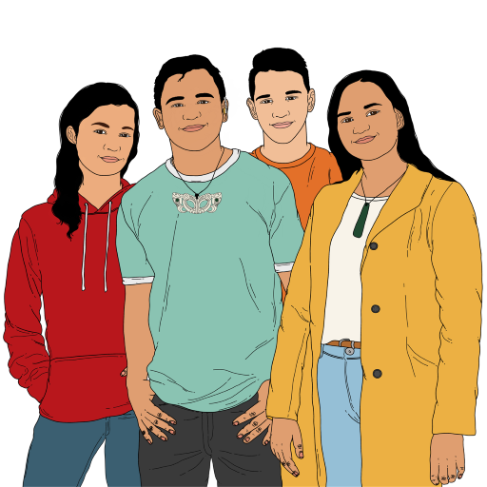
supporting younger tamariki to take part in decisions about their lives
let more tamariki and rangatahi know about:

- Transition Support Services
- how they can be supported as they become adults.
The other 2 priority areas are to:
make tamariki and rangatahi safer
support tamariki and rangatahi to have their voices heard more.

We will be doing lots of things to take action in the 4 priority areas.

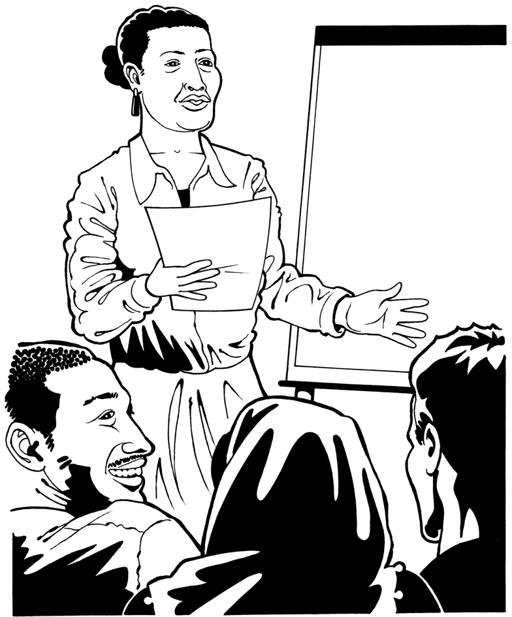
To support tamariki and rangarahi to be part of making more decisions about their lives our social workers will get more:
training
support.


Tamariki and rangatahi will have their voices heard more with new:
tools

technology
ways to tell us what they think.

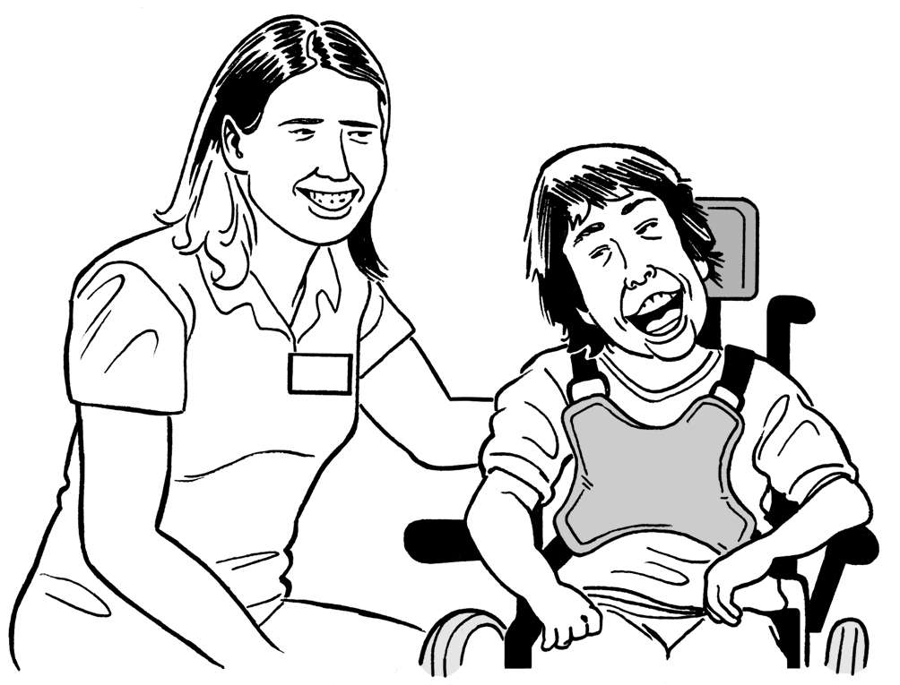
What they tell us will then be used to support their care needs.

Social workers will be able to better support rangatahi as they grow into adults through:
new training

better support for
- planning
- sharing information.

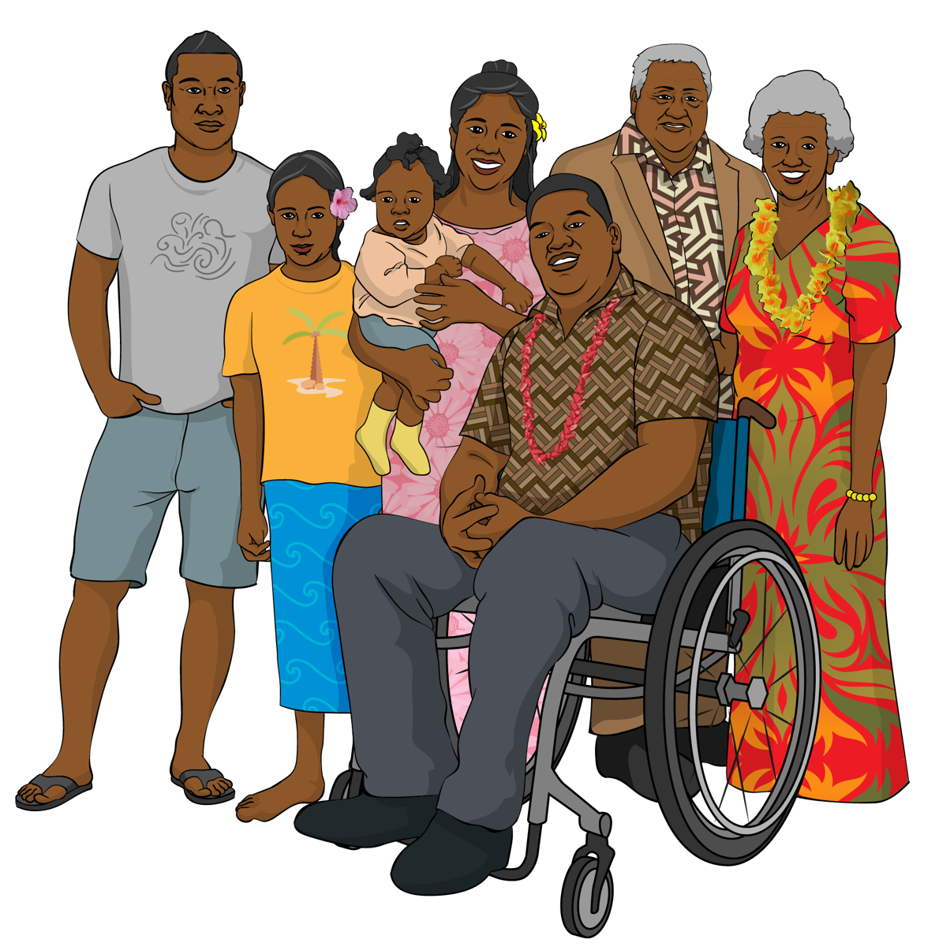
We will have a more accessible Report of Concern process for:
whānau / family

professionals
members of the public.

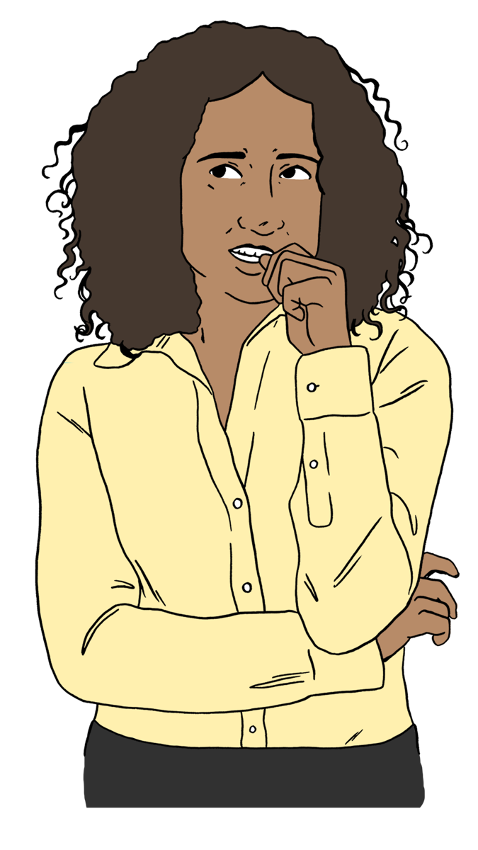
A Report of Concern is how anyone can tell Oranga Tamariki they are worried about the safety of tamariki.

Here accessible means easy for most people to use.
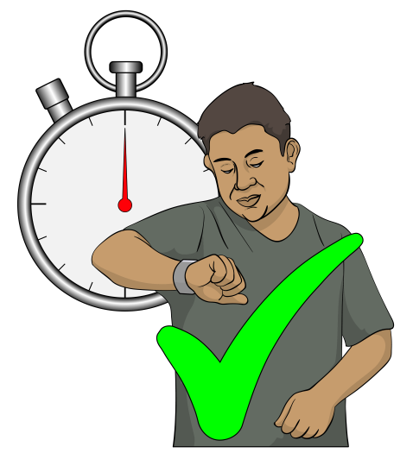

This will support us to respond to any worries quickly.

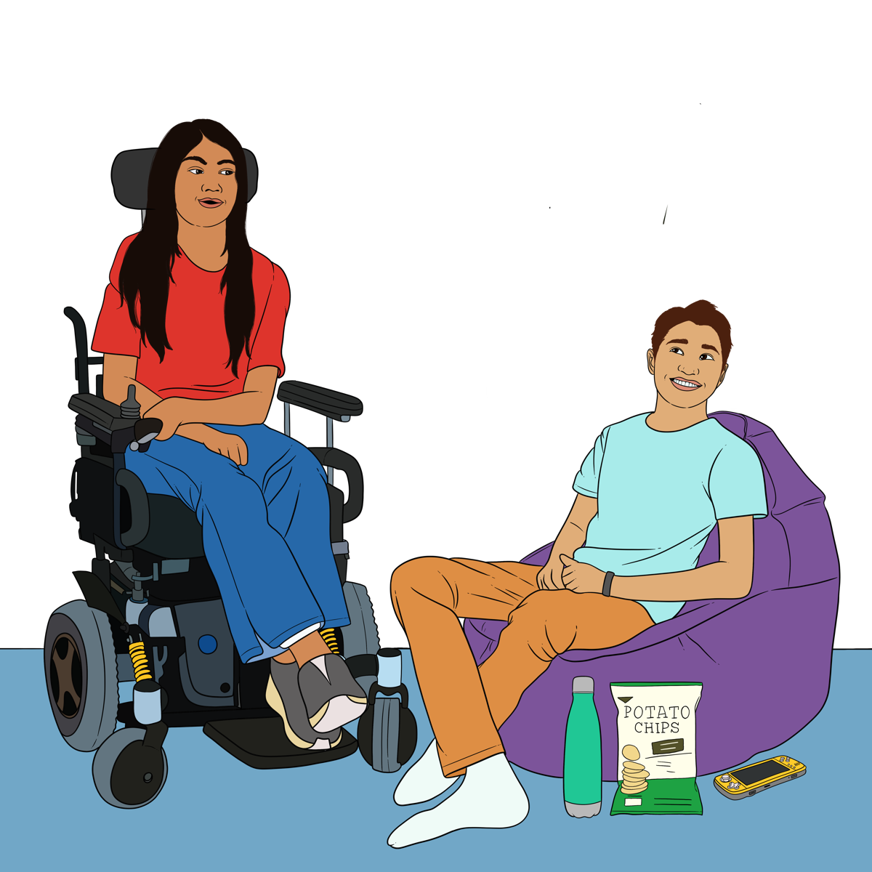
We will create better ways to understand the needs of disabled tamariki and rangatahi in care.


We will also create better ways of recording the needs of disabled tamariki and rangatahi in care.

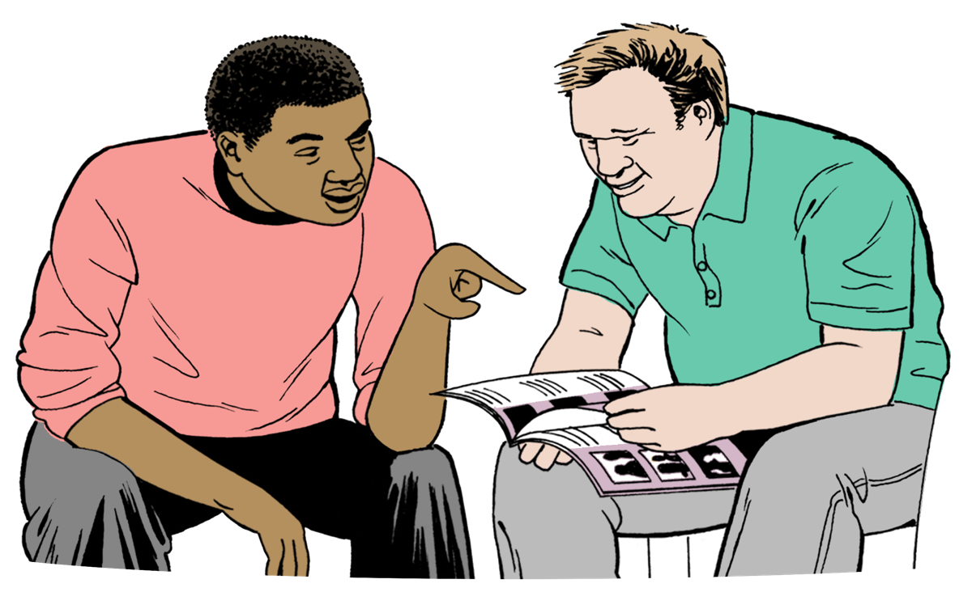
This will support disabled tamariki and rangatahi by supporting:
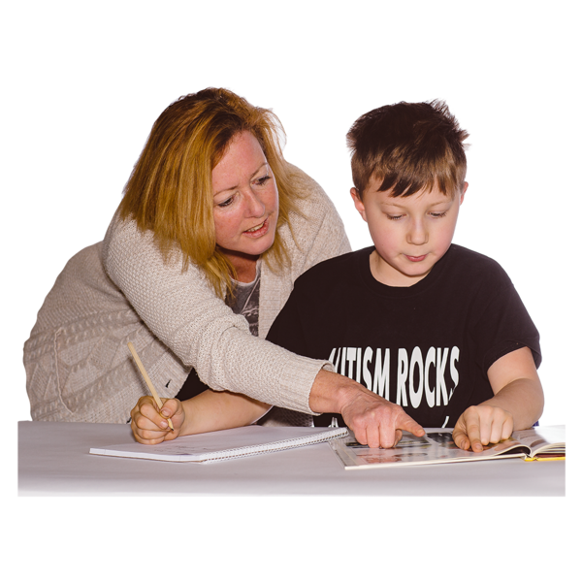
caregivers to know about any disability needs
us to put the right supports in place.

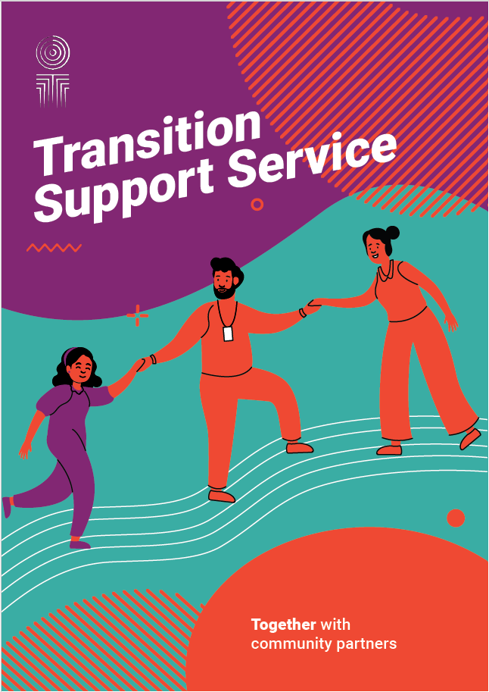
We will tell more people about:
Oranga Tamariki Transition Support Services
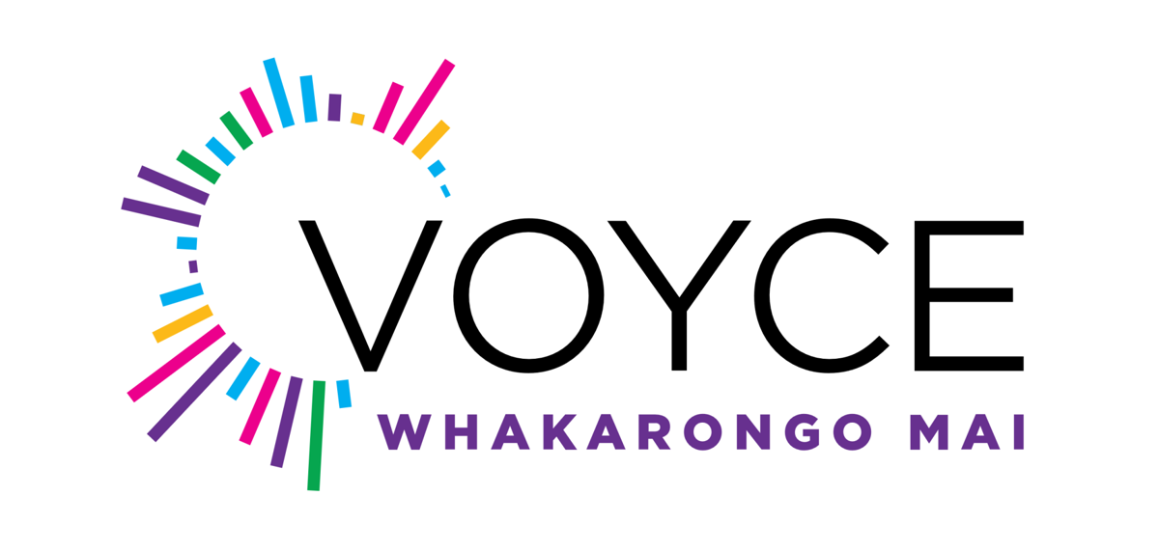
independent advocacy services from VOYCE – Whakarongo Mai.

Here independent means the people who work for VOYCE are not part of Oranga Tamariki.

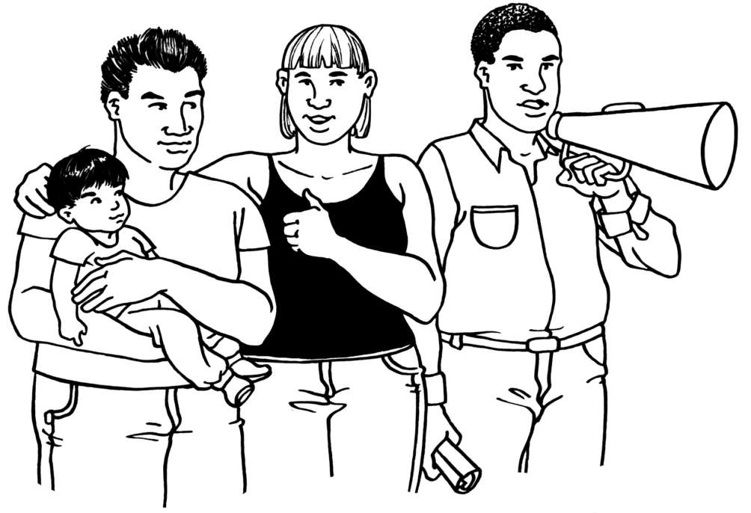
Advocacy services are a group of people who stand up for the rights of other people.

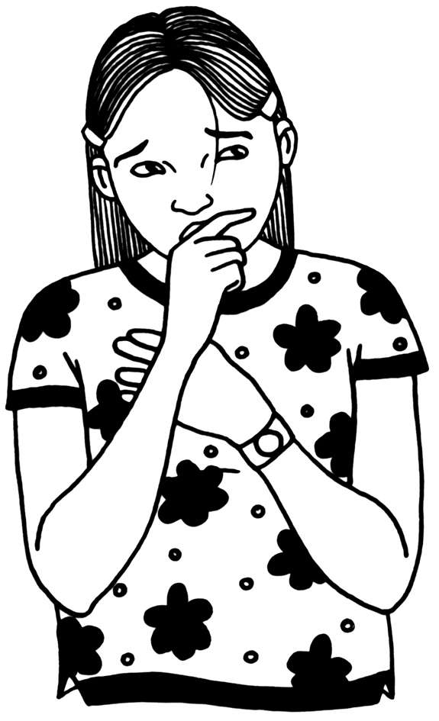
We will offer more ways for tamariki and rangatahi in care to:

let us know if they are worried about something
tell us what they think
ask for advocacy services.

We will keep running Te Tohu o te Ora so we can hear from tamariki and rangatahi about their experiences in care.

Contact us

You can contact Oranga Tamariki:


through our website at:
www.ot.govt.nz

This website is not in Easy Read


by email at:
contact@ot.govt.nz
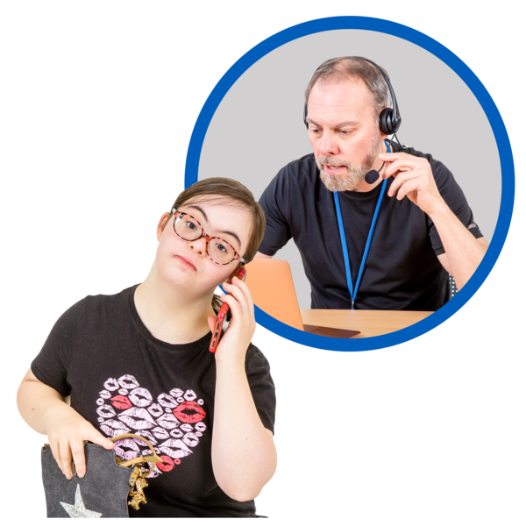
- by phone on:
0508 326 459


Our phone number will not cost you any money to call.


You can call us at any time.

Our phone lines are open all the time.

You can contact VOYCE Whakarongo Mai
through their website at:
www.voyce.org.nz

This website is not in Easy Read.
by phone on:
0800 486 923
You can also contact VOYCE Whakarongo Mai by email at:
contactus@voyce.org.nz

You can contact the Transition Assistance helpline:

by email at:
transitionsupport@ot.govt.nz
- by phone on:
0800 55 89 89

This phone number will not cost you any money to call.

You can call them at any time.
This information has been written by Oranga Tamariki Ministry for Children.

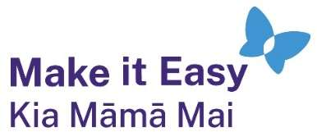
It has been translated into Easy Read with advice from the Make it Easy Kia Māmā Mai service of People First New Zealand Inc. Ngā Tāngata Tuatahi.
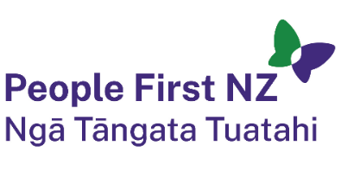
The ideas in this document are not the ideas of People First New Zealand Ngā Tāngata Tuatahi.

All images used in this Easy Read document are subject to copyright rules and cannot be used without permission.


Make it Easy uses images from:

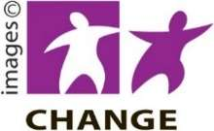
- Photosymbols

- Change Images



- Huriana Kopeke-Te Aho

- SGC Image Works


- T Wood

- Studio Rebeko.

