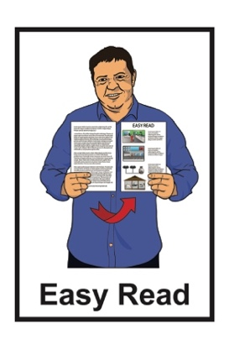

How to tell us what you think about our Disability Strategy
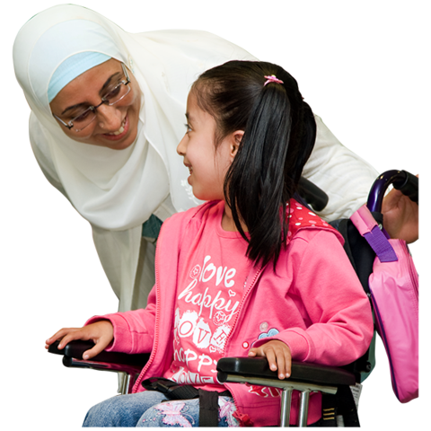

Published: June 2023

About this document

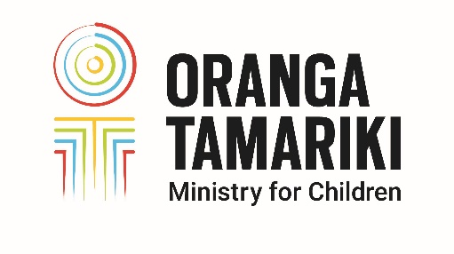
This document is from Oranga Tamariki which is the part of government that works on things to do with children.
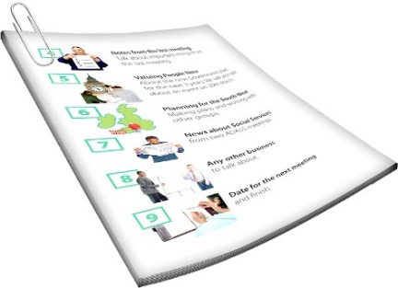

When we use the word we in this document it means Oranga Tamariki.

This document is about how to have your say about our disability strategy.

A strategy is a plan for how we are going to make things happen.

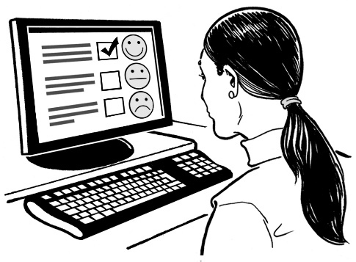
We want to know what you think about the disability strategy.

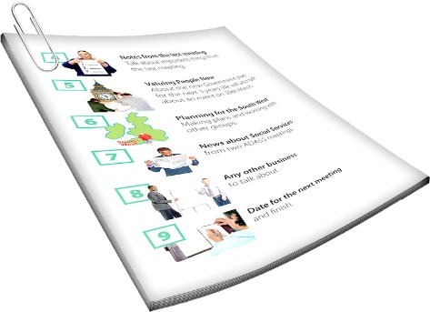
This document tells you about:
- how we have been working on a disability strategy
- the 4 shifts that we think need to happen.

A shift is a change in:
how we think
what we do.

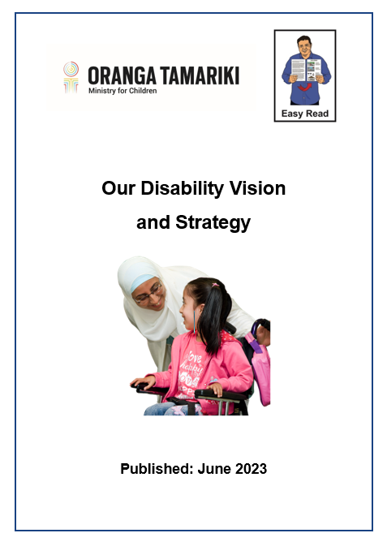
There is an Easy Read document called:

Our Disability Vision and Strategy

You can find this document at:

https://tinyurl.com/znr5b3d9
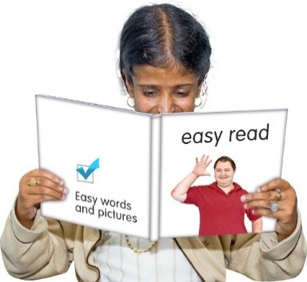

You need to read the Our Disability Vision and Strategy document before this one.

How to have your say

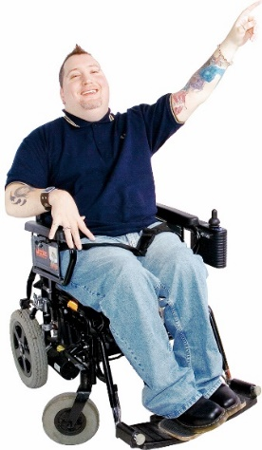
This document has some questions about each of the 4 shifts.

You do not have to answer questions about all the shifts.

If you like you can choose which shifts you want to talk about.

You can tell us what you think by:
- writing in this form
- writing in another document
- making a sound or video recording.

You can:
- email us the file to:

disability.strategy@ot.govt.nz
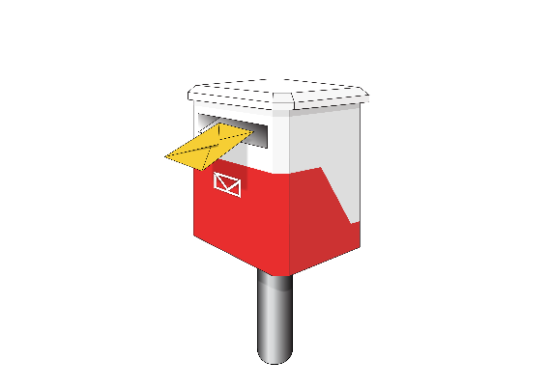
- post your document to:

Oranga Tamariki National Office

PO Box 546

Wellington

You can also talk to someone about what you think.

To make a time to talk to someone you can:

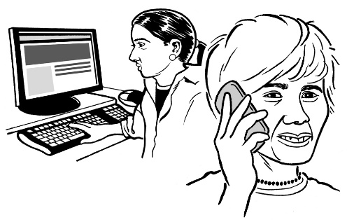
- email us at:

disability.strategy@ot.govt.nz

- phone: 0502 326 459

Questions about the 4 shifts

For each of the 4 shifts we will ask you some questions.

Do you agree with the ideas in the shift?

For this question you can tell us:
what you agree with
what you do not agree with
why you think what you do.

Are there any gaps or weaknesses?

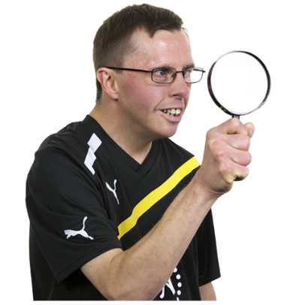
Gaps are things missing that you think should be there.

Weaknesses are where you think the shift:
may not work as it is meant to
may not be able to keep working if things go wrong.

For this question you can tell us what you think any gaps or weaknesses are.

What do you think are the 3 most important actions?

Actions are things we should do.

You can write your answers:
on the lines below each question
in a different document.

Shift 1: How we see disability

Do you agree with the ideas in
Shift 1?

Do you think there are any gaps or weaknesses in Shift 1?

What do you think are the 3 most important actions?

1.

2.

3.

Shift 2: Systems work for people

Do you agree with the ideas in
Shift 2?

Do you think there are any gaps or weaknesses in Shift 2?

What do you think are the 3 most important actions?

1.

2.

3.

Shift 3: Disability confident and competent workforce

Do you agree with the ideas in
Shift 3?

Do you think there are any gaps or weaknesses in Shift 3?

What do you think are the 3 most important actions?

1.

2.

3.

Shift 4: Oranga Tamariki is safe and proactive

Do you agree with the ideas in
Shift 4?

Do you think there are any gaps or weaknesses in Shift 4?

What do you think are the 3 most important actions?

1.

2.

3.

More information

You can find more information about the disability strategy at this website link:

https://tinyurl.com/txrzpwyp

You can also contact us:

by email:
disability.strategy@ot.govt.nz

- by phone: 0508 326 459
- by post:

Oranga Tamariki National Office

PO Box 546

Wellington
This information has been written by Oranga Tamariki Ministry for Children.

It has been translated into Easy Read by the Make it Easy Kia Māmā Mai service of People First New Zealand Ngā Tāngata Tuatahi.

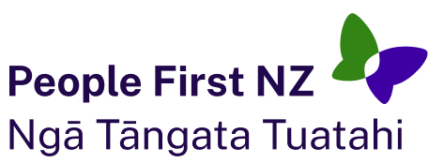
The ideas in this document are not the ideas of People First New Zealand Ngā Tāngata Tuatahi.

Make it Easy uses images from:

- Changepeople.org

- Photosymbols.com

- SGC Image Works

- Huriana Kopeke-Te Aho.
All images used in this Easy Read document are subject to copyright rules and cannot be used without permission.

