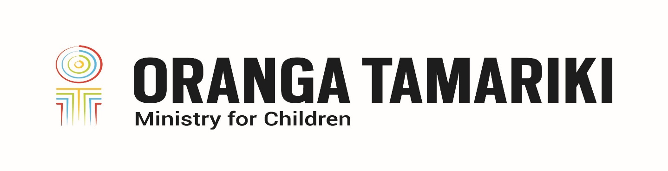
Oranga Tamariki Disability Strategy—How to make Individual Submissions
Adapted in 2023 by Accessible Formats Service,
Blind Low Vision NZ, Auckland
TN: Logo on the top of the page is: Oranga Tamariki Ministry for Children.

Oranga Tamariki Disability Strategy—How to make Individual Submissions
Our vision was developed in partnership with disabled people, their champions, tāngata whaikaha Māori and care experienced rangatahi.

How to make an individual submission
There are a number of ways you can participate in the development of the Disability Strategy:
- Written submission. Complete the following form and then email it to disabilitystrategy@ot.govt.nz
- Written statement emailed to Oranga Tamariki at disabilitystrategy@ot.govt.nz
- Audio or video recording sent to disabilitystrategy@ot.govt.nz
- Individual interview. Just send an email to disabilitystrategy@ot.govt.nz to organise a time.
You will notice from the Resource Material there are 4 Shifts as part of the Disability Strategy. You do not have to work through all 4 Shifts; just pick those that interest you if you prefer.
If you'd like any additional assistance or support please send an email to disabilitystrategy@ot.govt.nz and we will respond within 2 working days.

How we developed our vision
Oranga Tamariki knows that we need to work better with disabled people. To do this we are developing a Disability Vision and Strategy which will help us to use a social and rights-based model of disability grounded in the foundation of te Tiriti o Waitangi.
We have developed the vision and strategy in two phases. In Phase One we spoke to over 250 people including disabled people, tangata whaikaha Māori, pacific disabled people, care experienced young people, caregiving whānau, sector kaimahi, Oranga Tamariki kaimahi and service providers. After we spoke to everyone, we partnered with the Oranga Tamariki Disability Advisory Group and other partners and developed a vision, four shifts needed to achieve it, and a draft definition of disability.

Our vision
"The mana of tāngata whaikaha me o ratou toa (disabled people and their champions) is enhanced by meeting their needs, upholding their rights and supporting their hopes and dreams."
To achieve the Vision, we have identified Four Shifts that need to occur:
- How we see disability.
- Systems work for people.
- Disability competent and confident workforce.
- Oranga Tamariki is safe and proactive.
During the engagement we also heard some ideas on how to achieve these shifts.
There is more detail on the Vision, the Oranga Tamariki working definition of disability, the Four Shifts and the activities to achieve those shifts on the website.

Instructions
We want to hear your ideas and insights on how we can best achieve the Vision and the Four Shifts. Remember you only need to focus on the Shifts that interest you.
Review the Vision and each Shift in the format you prefer on our website. For each Shift please respond to the following questions:
- Do you agree with the ideas already recorded?
- Are there any gaps or ideas you would like to add?
- What would your 3 priorities be?

Your submission

Shift One—How we see disability
Do you agree with the ideas noted under Shift 1?

Are there any gaps or weaknesses?
What would your 3 priority actions be?

1
2
3

Shift Two—Systems work for people
Do you agree with the ideas noted under Shift 2?

Are there any gaps or weaknesses?

What would your 3 priority actions be?
1
2
3

Shift Three—Disability competent and confident workforce
Do you agree with the ideas noted under Shift 3.

Are there any gaps or weaknesses?

What would your 3 priority actions be?
1
2
3

Shift Four—Oranga Tamariki is safe and proactive
Do you agree with the ideas noted under Shift 4?

Are there any gaps or weaknesses?

What would your 3 priority actions be?
1
2
3

End of Oranga Tamariki Disability Strategy—How to make Individual Submissions

