Issue No.4
December 2019
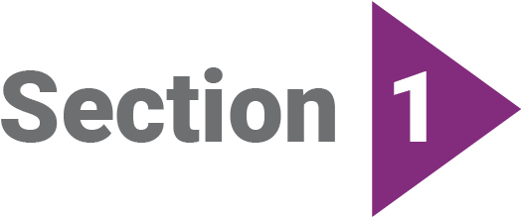
SErvices in Schools BiZ
Wise Up National Conference (3-4 October 2019)

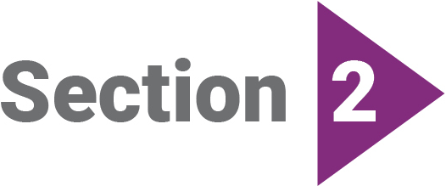
RESOURCES & QUALITY PRACTICE
Potential You Tube Video Channel
SWiS Resources
Te Mana O Te Wāhine

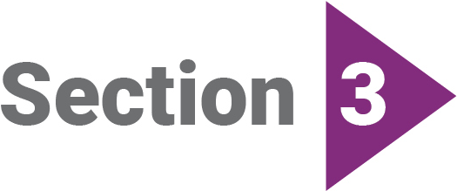
Strengths and difficulties questionnaire (SDQ)
Samoan Translation: Update
Dashboards
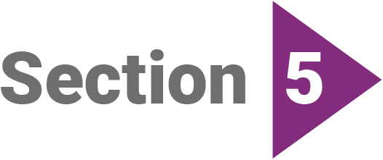
UPDATES FROM ORANGA TAMARIKI NATIONAL OFFICE
YWiSS/MASSiSS Review. Publication & Feedback Meetings
Budget 2019
Family Start
Language Supports
Staff Movements
Items for Future Issues
Whakatauki

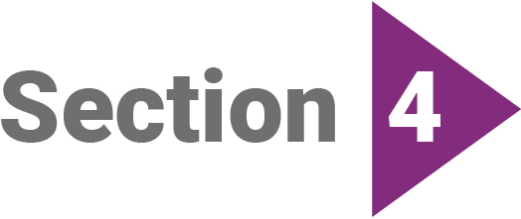
SwiS and Mana AKE
Te mahi tahi: Te Hunga Tauwhiro i te Kura me Mana Ake i Otautahi - Working Together: SWiS and Mana Ake in Christchurch

SErvices in Schools BiZ
Wise up national conference (3-4 october 2019)
The Wise Up (Workers in Schools Educate and Unlock Potential) conference was held on 3-4 October 2019 at the Vodafone Events Centre in Manukau City.
The conference website is: www.wiseup.org.nz
This was a successful event as the post-conference evaluation revealed. Links to all of the Workshop and Keynote presentations/Powerpoints have now been added to the conference website.
This website is a great place to go to find out about the sessions you missed! For those social workers that could not attend, the website is a wide-ranging library of resources that can be discussed at Team meetings etc.

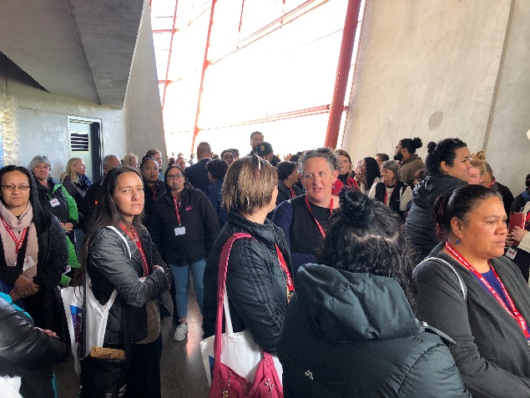
Wise Up crowd scene. En route to the workshops!

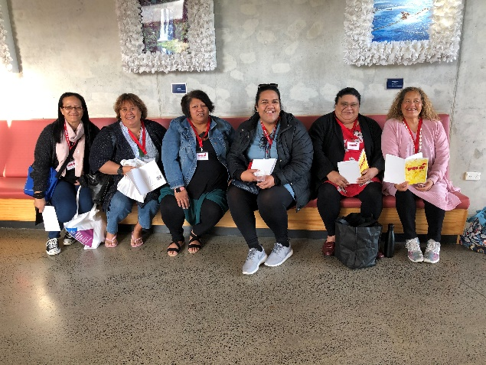
ATWC (Auckland) and Te Rarawa Nga Mua Trust (Kaitaia)
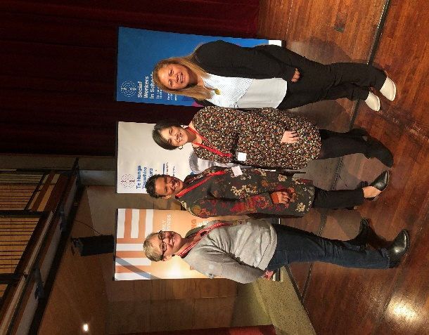
(from left) – Michele Olds (Oranga Tamariki), Henriette Taylor, Rachel Donegan (University of Maryland School of Social Work); Judy Matai’a (ATWC)
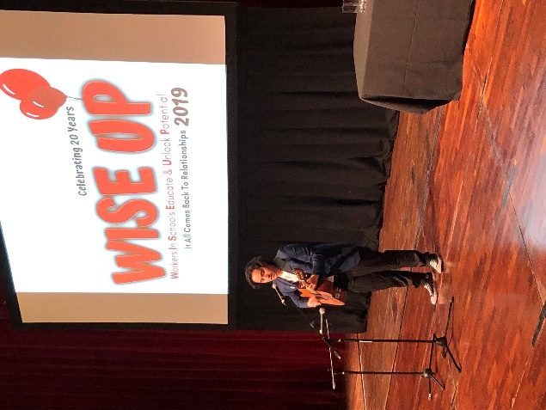
Musical performance, Day One. Flo Mariner

‘Talking with teachers’ presentation
The current and future issues of this newsletter will feature short write-ups of paper highlights.
One Workshop session was “Talking with Teachers” by Rachel Knappstein [Resources slides and full Powerpoint of presentation available at wiseup.org.nz]. This workshop was SWiS-focused but could be adapted to other school-based services such as YWiSS or MASSiSS.
Highlights of this presentation includes a double-sided diagram of “Trauma in Children and Young People” – How to Respond and What does this look like in school?” This colourful diagram would be an excellent one to print out in A3, laminate and put on your office walls.
Highlights of Rachel’s presentation included a number of tips for how best to communicate with teachers, including:
- Practical tips on introducing the role of the social worker (SWiS)
- Explaining the need for the SDQ to teachers to increase completions
- A template for “A Note from SWiS” and a postcard for any messages the child might want to convey to the teacher via a SWiS social worker
- Sharing social work knowledge and insights.

RESOURCES & QUALITY PRACTICE

POTENTIAL YOU TUBE CHANNEL
We have had a suggestion from one of our providers about getting training out to Services in Schools (SWiS, YWiSS & MASSiSS) practitioners – such as webinars and videos of training sessions. One method to do this could be to set up a dedicated You Tube channel.
We would like to gauge interest in this idea from practitioners and their organisations in receiving and contributing to this resource. It would most probably be a channel that can be set up and then updated using links we can send out.
Please email feedback on this idea to: michele.olds@ot.govt.nz

SwiS resources
Note that we now have additional SWiS Resources available – all available by contacting your Partnering for Outcomes Advisor. Unless noted otherwise, bundles of these resources have been already been sent to all providers for distribution to individual social workers – so if you have not received these resources yet, talk to your line manager.
SDQ POstcards – We have re-designed both postcards on the SDQ, with a white background. Content is the same, including being double-sided. To add to the existing English/Te Reo Māori cards we now also have these available in English/Samoan.
SDQ postcard (Cross-agency) - We have produced a card that can be used not only by Services in Schools practitioners, but also by those in the Health (B4School) and Education sectors (Gateway). This resource was developed with the endorsement of the Ministries of Health and Education, indicating that the SDQ is used by multiple services and agencies across the lifespan.
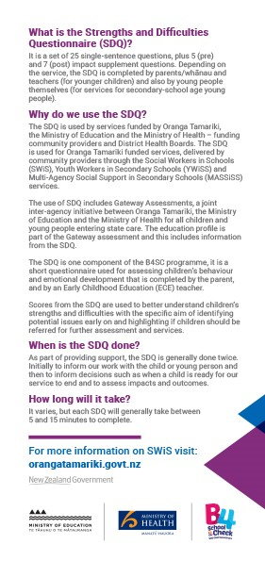

SwiS banners - These pull-up banners made their debut at the Wise Up conference. We have limited numbers at the Oranga Tamariki offices in Ellerslie and at National Office in Wellington. Contact marten.hutt@ot.govt.nz if you would like to use these banners as part of open days etc for your schools.

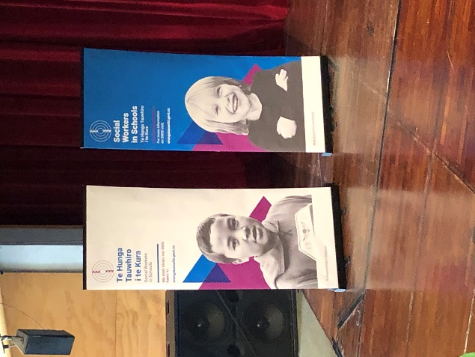

SwiS teardrop flags - Over the next few years we will try and get these teardrop flags to those providers that want them, at no cost. A small number of Auckland-based providers have already received some, following them being on display at Wise Up.
Contact marten.hutt@ot.govt.nz if you are interested in receiving one of these flags as part of the 2020 production run. Note that the flags are double-sided, i.e. the other side of the flag shown in the image overleaf is the Te Reo Māori version of the SWIS brand.
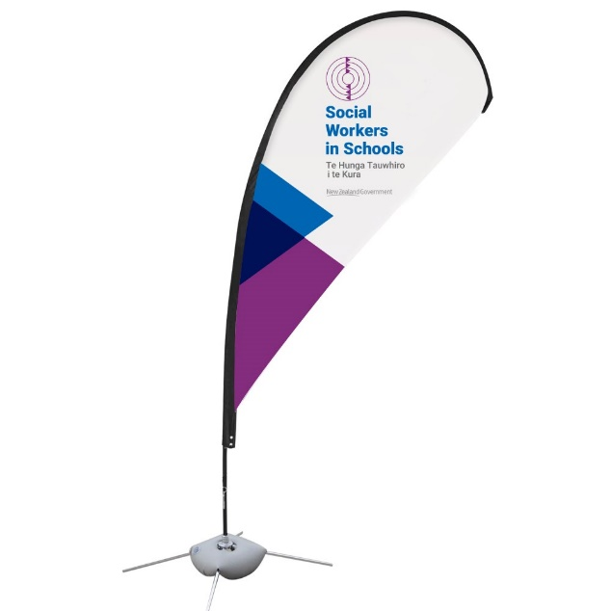

Te mana o te wāhine
This description of a SWiS Group programme has been supplied by Awatea Tupe, SWIS social worker for Hinengakau Maatua Whangai in Taumarunui.
Te Mana O Te Wāhine is the group programme shared with Year 7 and 8 girls from Manunui Primary School.
Te Mana O Te Wāhine explains the roles and responsibilities of women from a Māori World View (Te Ao Māori). It was developed from the research writings of Rawinia Higgins and Paul Meredith.
At the beginning of the programme the girls set the kawa (rules and guidelines for the programme). Each session begins with whakawhanaungatanga and karakia.
The group learn that in Te Ao Maori females are te whare tangata (the house of man) and that they were venerated and respected for their ability to create life.
The subjects discussed in detail are Te Whare Tangata, Tapu and Noa/Whakanoa, Women of rank and the specific roles that they held, Peacemaking, Moko Kauae, Karanga, Whaikorero, Waiata and
composers of waiata both historic and modern.
When I facilitated this group we had a mokopuna of one of our famous composers Puhiwahine who composed a well-known waiata “Ka Eke Ki Wairaka”.
The group I am thinking of while writing this piece began with four girls who were experiencing behavioural problems. However, the group grew to include all Year 7 and 8 girls and the group grew to thirteen. The programme ran for twelve months at Manunui School and will begin again in the New Year for another group of students.
This group comprised 60% Māori and 40% Pākeha students. Although this programme was Kaupapa Maori, I ensured that the learning environment was safe and inclusive. This allowed all students to participate and ask questions. The Pākeha students felt that this programme allowed them to openly contribute, engage and ask questions without fear of ridicule or feeling shy. They were open to the learning and participated fully in every subject matter.
The programme’s success was that these young ladies were given an insight into the roles and responsibilities of women and that the values and beliefs upheld by our tupuna (ancestors) are still very relevant in today’s world. Their behavior issues were greatly reduced as a result of their learning.

Strengths and difficulties
questionnaire (SDQ)
Samoan tRanslation: Update
The SDQ has been translated into Samoan through the Department of Internal Affair’s Translation Service. The translations were sent out to a selection of Services in Schools providers for consultation/review. The questionnaires are now with the SDQ licence holder in the United Kingdom for sign-off and upload to their website.
We will advise Services in Schools providers/workers and other users (Health & Education sectors) when the Samoan SDQ is available online.
DASHBOards
A big thank you to all providers that sent in their SDQ spread sheet reports for the 2nd round of SDQ reporting (11 December 2018 to 30 June 2019). These have been analysed, designed in graphical form (‘Dashboard’) and redistributed back to your organisation.
Please note: We are looking forward to seeing the next round of these spread sheet reports in December (covering the period 1 July to December 2019). You can expect a return on these in January 2020. Please send your organisation’s SDQ Reporting Template to your Partnering for Outcomes Contract Manager.
Please feel free to contact us with any suggestions about improvement for the dashboards. We would also like to hear how you are using the dashboards, e.g. to inform/be distributed at cluster/governance meetings etc.
SWiS & MANA AKE

Te mahi tahi: Te Hunga Tauwhiro i te Kura me Mana Ake i Ōtautahi Working together: SWiS and Mana Ake in Christchurch
This article has been submitted by Kath Harrison (Pou Heke – Team Leader SWiS, Stand Tū Māia– Ōtautahi)
The SWiS service has been established within the low-decile school community of Ōtautahi/Christchurch since 1999. The service has evolved over subsequent years in response to the needs of local communities and incremental contractual expansions. Currently, fourteen practitioners employed by Stand Tū Māia and Family Works, deliver the service to over thirty schools across the city.
The Mana Ake – Stronger for Tomorrow initiative was established in March 2018 in response to the concerns raised by schools and services who were seeing a sharp increase in tamariki presenting with anxiety-related concerns post quakes.
The service is led by the Canterbury District Health Board and will place 80 front-line kaimahi into the Years 1-8 school space, as an initiative to enhance the wellbeing of tamariki and whānau. In just over a year, the service established a provider network of 13 community service provider organisations and rolled the service out to 220 primary and intermediate schools from Ashburton to Kaikoura.
The sheer magnitude of the Mana Ake project has generated unique opportunities for tamariki and whānau community services to meaningfully influence systemic change within the education sector. A comprehensive suite of collaboratively-developed and continually-evolving trainings, resources and guidelines are available to Canterbury school staff, via the online platform Leading Lights, to support the sector in recognising and responding to the wellbeing needs of tamariki and whānau.
The introduction of wellbeing support to all primary and intermediate schools across Canterbury, has been a welcome variation to the usual decile-driven model. The Mana Ake project team have drawn together a substantial multidisciplinary workforce of psychologists, social workers, counsellors, teachers and youth workers, via a collaboration of kaupapa Māori, faith-based and other community service providers who bring an exciting array of knowledge, skills and approaches to our shared work.
It would be unrealistic to expect such a huge endeavour to go without a hitch. Indeed, the swift accumulation of 80 practitioners has undoubtedly created gaps elsewhere and added to recruitment challenges in a sector already struggling to attract and retain staff in roles and where fair pay and pay parity issues are being raised. The addition of more people in an already congested workspace has placed additional pressure on schools, many of whom are in the midst of total rebuilds and major repairs post-earthquakes.
The amalgamation of diverse skills, professions and service providers brings complexities regarding ethical codes, practice approaches, and professional frameworks. What may be embraced as a diverse and eclectic range of service styles in one context, may be considered inconsistent, unclear and unreliable in another. Understandably, the Mana Ake brief has evolved as the service has bedded in, however the constant development has been challenging and unsettling for some schools.
Within the low-decile school community, the introduction of Mana Ake alongside SWiS has created both opportunities and challenges. SWiS workers have benefitted from having professional allies in what can sometimes be an isolating context. The close availability of colleagues allows for peer support, informal supervision, and enhanced professional safety. Some of the most successful examples of SWiS/Mana Ake collaboration have been the co-facilitation of group programmes.

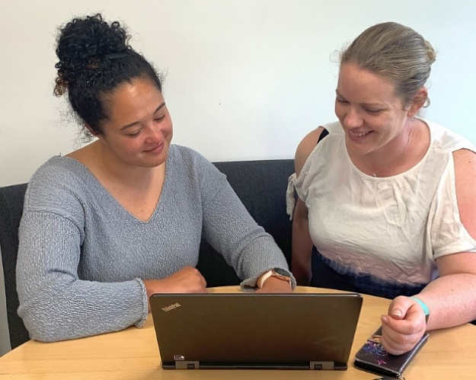
Mia Bauckham, SWiS and Laura Hay, Mana Ake review a group programme plan

In schools already serviced by SWiS, Mana Ake Kaimahi have been encouraged to remain in the preventative space working with tamariki and whānau experiencing mild to moderate wellbeing issues. The ability of SWiS to work across the spectrum of need had previously been beneficial in moderating potential negative perceptions of the role, as well as encouraging worker wellbeing and retention. In contrast, schools without SWiS see Mana Ake Kaimahi often drawn into responding to complex cases.
The role of Special Education Needs Coordinators (SENCO) has become increasingly pivotal in the effective implementation of school based tamariki and whānau support services. Increasingly complex tamariki and whānau presentation and segmented support services, increases expectations for SENCO’s to be able to distinguish between mild, moderate, and complex issues, and determine whether their origins are physical, mental, emotional, cognitive, behavioural, social, whānau-based or school-based, in order to refer to the appropriate service supports.
With a school being the place where a child’s needs might be first raised, the SENCO role carries significant power and responsibilty. Assessing multiple needs and navigating referral pathways can be further complicated when the provision of particular services may vary from worker to worker. As always, it all comes back to relationships. Where SENCO’s, SWiS and Mana Ake create a collaborative culture that fosters trust and communication, these complexities can be successfully navigated and challenges overcome.
Waiho i te toipoto, kaua i te toiroa – Let us keep close together, not far apart

UPDATES FROM ORANGA TAMARIKI NATIONAL OFFICE
YWiSS & MASSiSS Review. publication & FEEdback meetings

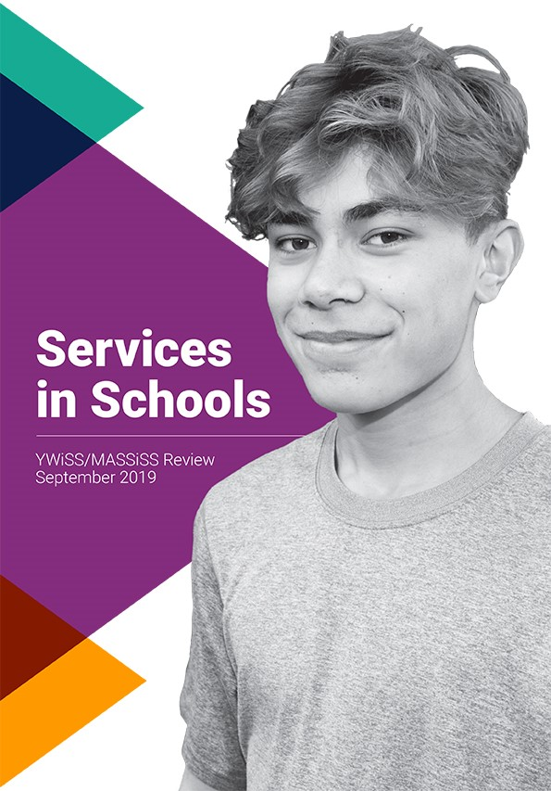

Over October-December 2019, Oranga Tamariki National Office has been holding meetings with providers and workers of the secondary school-based YWiSS and MASSiSS services.
These have been to report back on a completed publication: Services in Schools. YWiSS/MASSiSS Review. The report covered findings from meetings with these providers and workers as to what key issues and opportunities relating to service practice and resource requirements there were.
Following the final meeting, in early December, we will make the report available on the Services in Schools web pages. We will use this newsletter to advise of updates on improvements and new resources developed with the workers and providers of these two services.

BUdget 2019
As part of the Wellbeing Budget 2019, the Government allocated $26.7 million over four years to meet cost pressures on NGO social service providers, including the added challenge resulting from the Oranga Tamariki social worker pay equity settlement. The Budget 2019 funding has allowed for a basic increase for all contracted service providers.
Oranga Tamariki has added to that increase, from within its existing budget, for those services that rely on social workers or similarly skilled workers. This took the total increase for those services, including Services in Schools (SWiS, YWiSS, MASSiSS), to 7.5%.
Oranga Tamariki wrote to all providers in late July and early August advising them of this increase and when the increase would be paid. Oranga Tamariki recognises that contracted providers manage their finances in a variety of ways and it does not prescribe the method and timing for addressing wage pressures. This means any increase may flow through to social workers in different ways and at different times.

Family Start
Are you working with a whānau where there are younger children in the home? Family Start is a nationwide home visiting programme for vulnerable children (aged 0-5) and their families. This Oranga Tamariki-funded programme provides a free, voluntary home visiting service that supports families/whānau who struggle with challenges or problems that put health, education and social outcomes for their children at risk.
Family Start is for families with mental health issues, addiction problems, care and protection history, relationship problems, parenting and child development issues or other issues. Family Start is child centred and whānau focused. Older and younger children are able to be supported through Family Start - support for siblings and other whānau is important for the development of children in their whānau and environmental context. Anyone can make a referral to Family Start however they must meet a certain criteria before being accepted onto the programme.
For more information on the referral criteria please click on the link: https://www.orangatamariki.govt.nz/assets/Uploads/Family-Start/Family-Start-referral-guide.pdf
To find out who the Individual Family Start provider is in your region, please use the following link: https://www.orangatamariki.govt.nz/assets/Uploads/Family-Start/Family-Services-Directory-Family-Start-Provider-List.pdf

language supports
A number of you are starting to see increasing numbers of refugee and migrant children on caseloads. This is as a partial result of resettlement into provincial areas. This has led to demands to language interpreting services and in a wide number of languages.
Language supports will be an ongoing topic within this newsletter in future issues and we will use this avenue to update on developments. There are a number of language-related initiatives and processes potentially coming available in early 2020 and we want to ensure SiS providers have all the information they need. This is a complex, fast-moving area.
The Ministry of Education has approved us advising SiS providers that they are welcome to contact their regional Senior Advisors Refugee and Migrant Education, for the purpose of sourcing support (e.g. interpreters) for families you are working with.
Note that there may be fiscal constraints (funding for language supports is not explicitly allowed for currently in your FTE rates/contracts).
Also you will be mindful of using an appropriate person to interpret – for instance Bilingual Support Workers (BSWs) in schools should not generally be approached to provide interpreting for working with families. There are privacy issues to consider, and the BSWs are not trained as interpreters. Many of you may be using local solutions in the interim.
It will, though, be helpful to let the Ministry of Education’s regional advisors know that you are working with families in schools, as they know what support is available in those schools.
Contacts for Senior Advisors Refugee and Migrant Education are:
Dunedin (Southland) - Rula Y. Talahma rula.talahma@education.govt.nz
Christchurch (including Nelson, and Blenheim areas) - Mastura Abd Rahman Mastura.abdrahman@education.govt.nz
Lower Hutt (Central Wellington, Masterton) - Maureen Zaya Maureen.zaya@education.govt.nz
Lower Hutt (Porirua, Palmerston North) -Carolina Millar Carolina.millar@education.govt.nz
Hamilton (Bay of Plenty, Waikato and Whanganui) - Afat Xiao afat.xiao@education.govt.nz
Abdirizak Abdi - (Hamilton and National Lead Advisor) Abdirizak.abdi@education.govt.nz
Auckland (including Northland) - Asma Shah and Adel Salmanzadeh
asma.shah@education.govt.nz
Adel.salmanzadeh@education.govt.nz

staff NEWS
Min Vette is currently on secondment to the Policy Team within Oranga Tamariki National Office from her Team Leader role with Pā Harakeke- Community (which covers SWiS, YWiSS, MASSiSS and Strengthening Families).
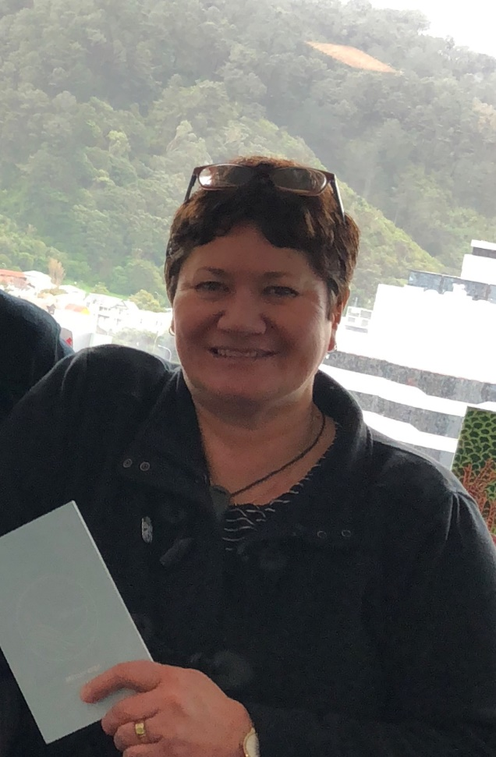

Thomas McGloin, who many of the readers of this newsletter will remember from his SDQ training days, and being available to Services in Schools workers and providers for SDQ-related advice, is now living in London.
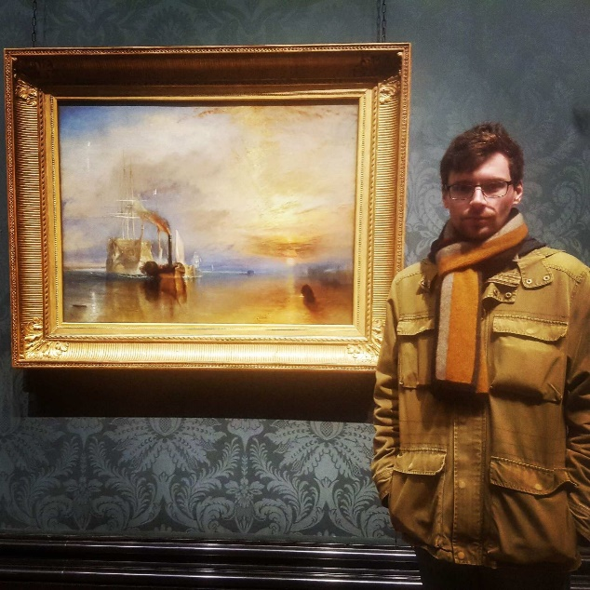

Items for Future Issues
We welcome items submitted in all languages.
We are currently seeking (in particular), items on:
- Working in Secondary Schools (YWiSS and MASSiSS)
- The ways you are making use of SDQ Dashboards.
Please feel free to comment on any item in this newsletter, or send in submissions (signed off by Team Leaders/managers) for future issues.
Please email: marten.hutt@ot.govt.nz

whakatauki
Ko ngā pae tawhiti whāia kia tata. Ko ngā pae tata whakamaua kia tina
– Pursue the distant horizons so that they draw near. As for the opportunities to hand, seize them.

